Emergency Numbers are important.
Make your own list. Here are some suggestions.
You may add more.

Phone number for Fire and Ambulance is… | 9-1-1
Phone Number for the Police is… | 9-9-9
My home phone number is…
The phone Number for my Mummy at work is…
The phone Number for my Daddy at work is…

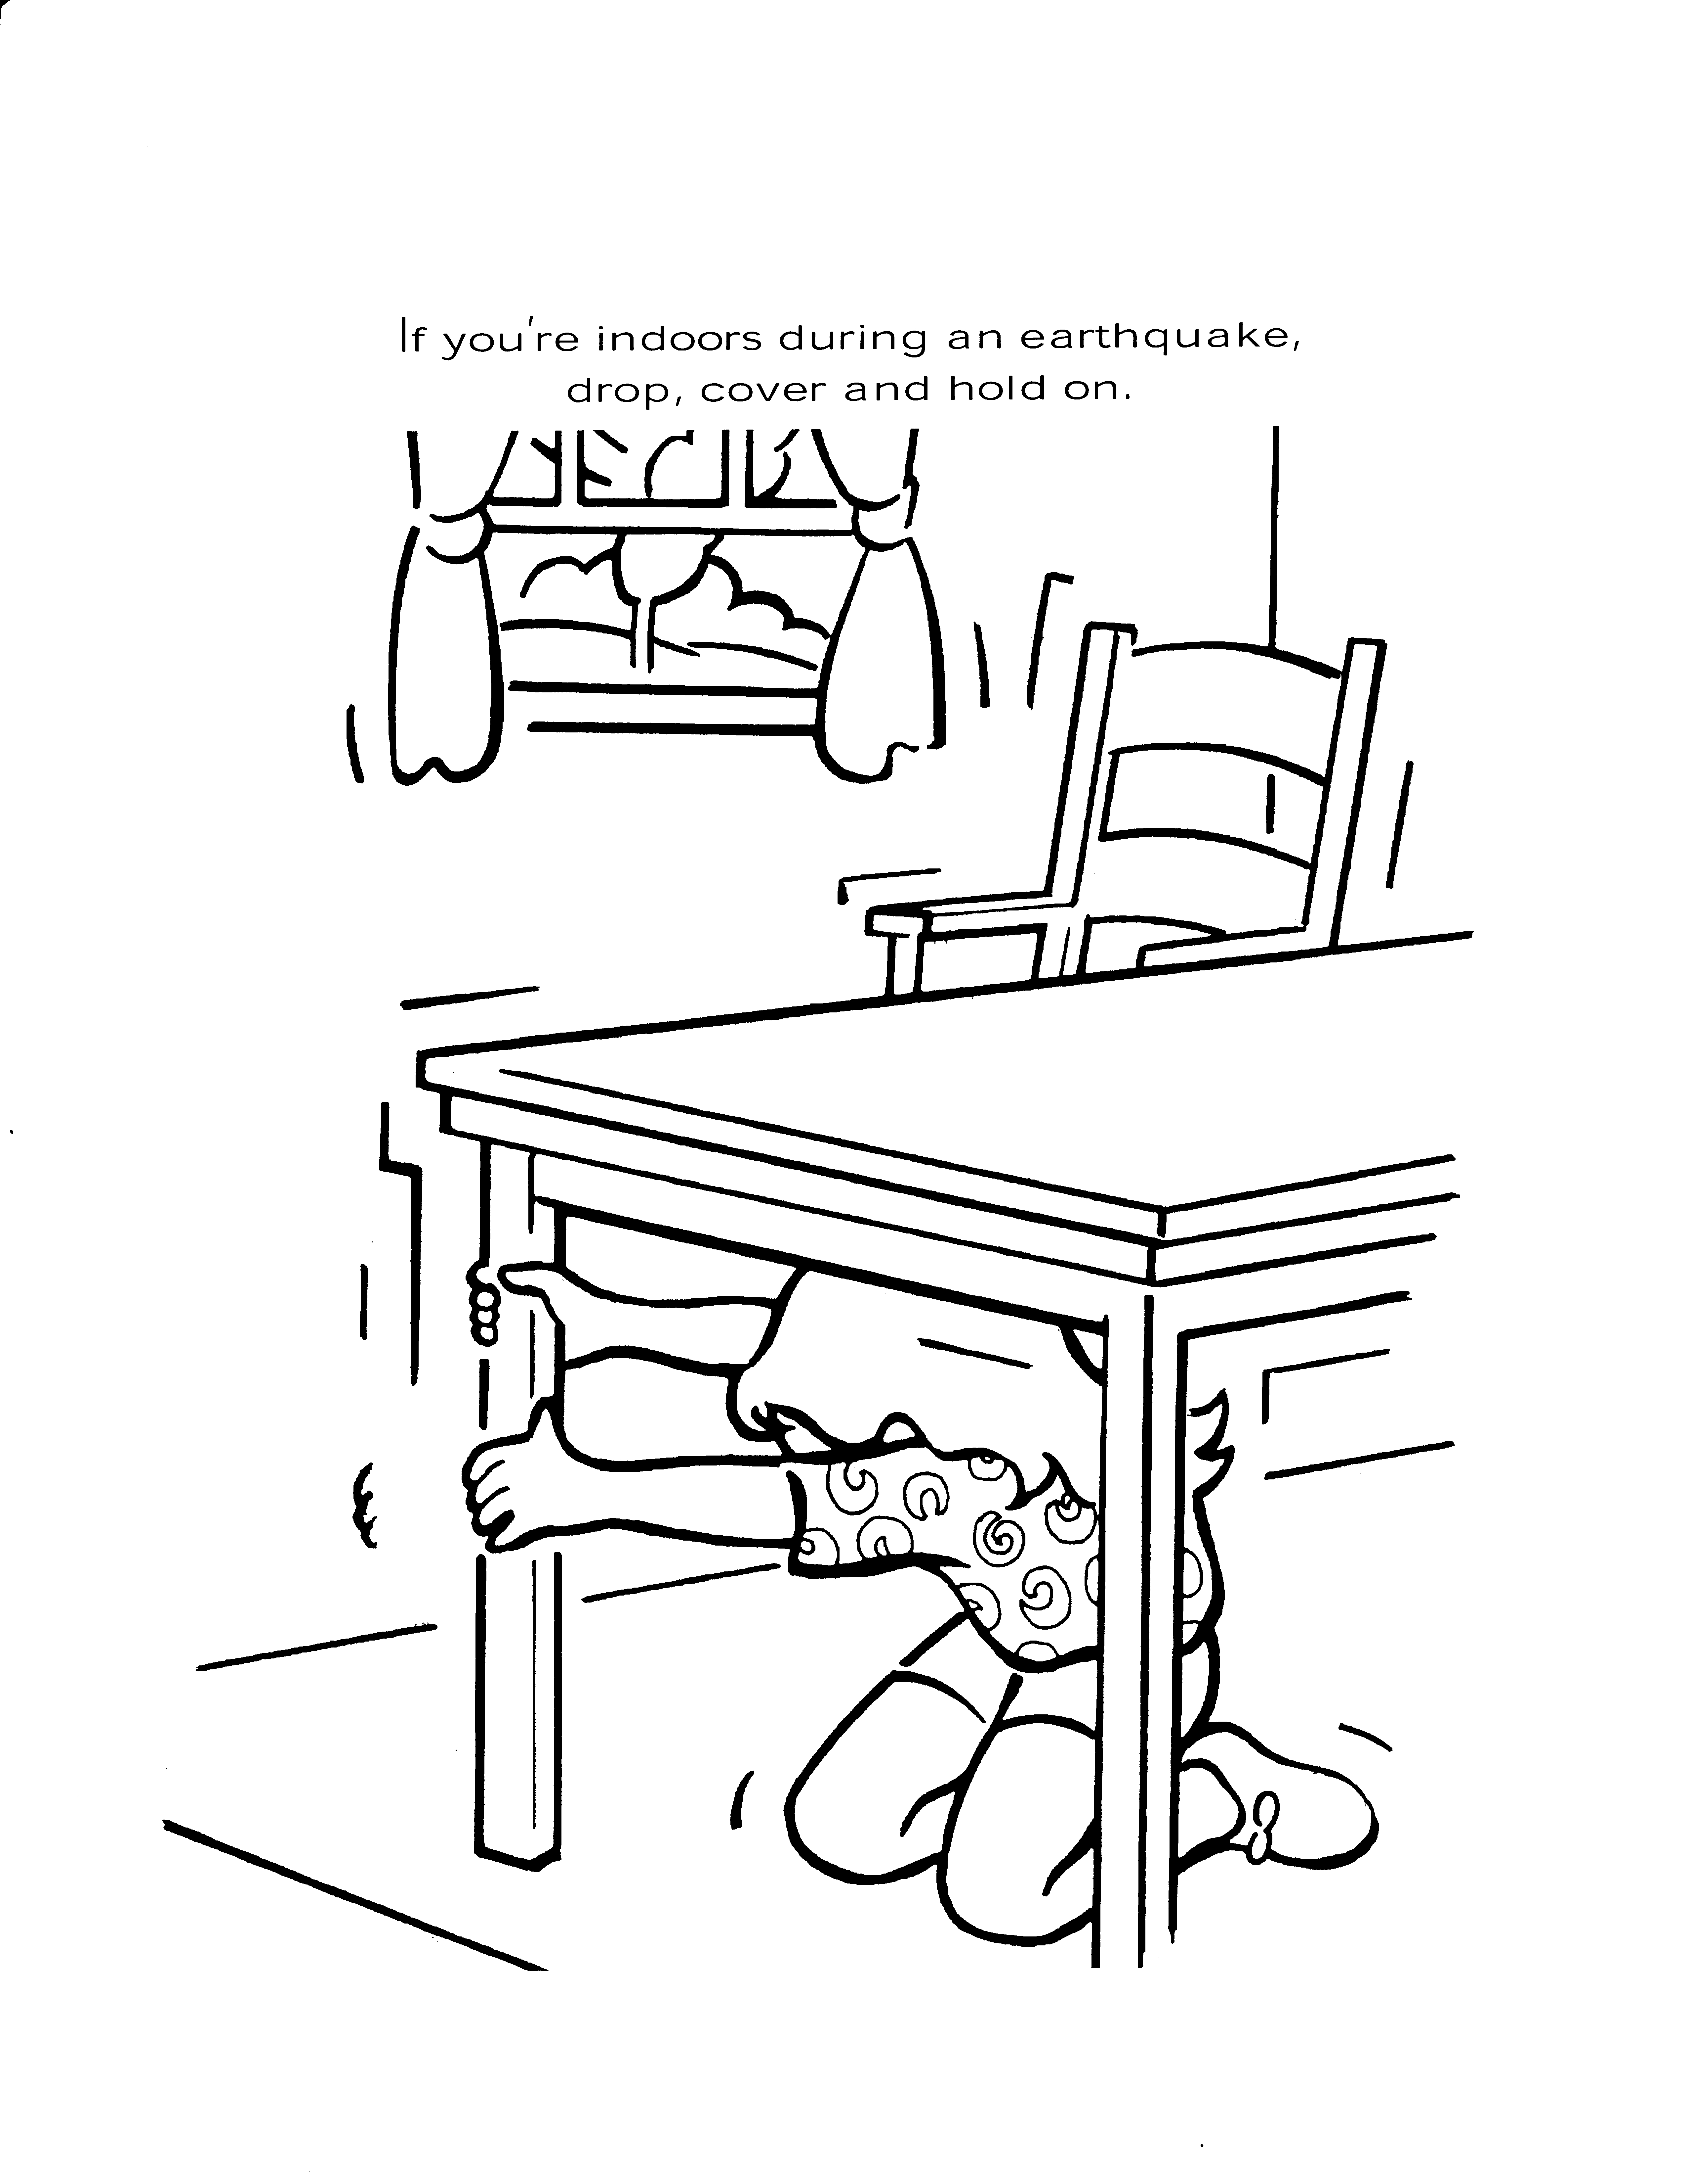
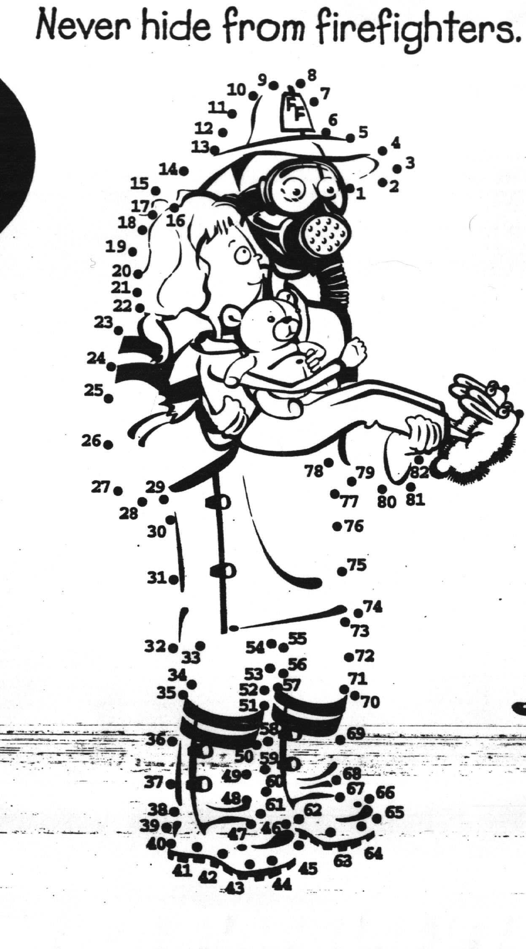
Join the dots...
Don’t be afraid of firefighters

In case of fire, they can help you escape
Produced with the kind permission of The US Fire Administration.

