EDITH

Exit
Drill
In
The
Home
DECIDE

Detect
Estimate
Choose Objectives
Identify Options
Do the Best
Evaluate Progress

SMART

Specific Measurable Attainable Realistic
Time Bound
TEAM

Together
Everyone
Achieves
More
NEMO

Now
Everyone
Must
Organise

Emergency Numbers are important.
Make your own list. Here are some suggestions.
You may add more.

Phone number for Fire and Ambulance is… | 9-1-1
Phone Number for the Police is… | 9-9-9
My home phone number is…
The phone Number for my Mummy at work is…
The phone Number for my Daddy at work is…
Hospital/Health Centre

Veterinarian

How many words can you make out of the letters in DISASTER?

________________________________
________________________________
________________________________
________________________________
________________________________
________________________________
________________________________
________________________________

Colour the picture.

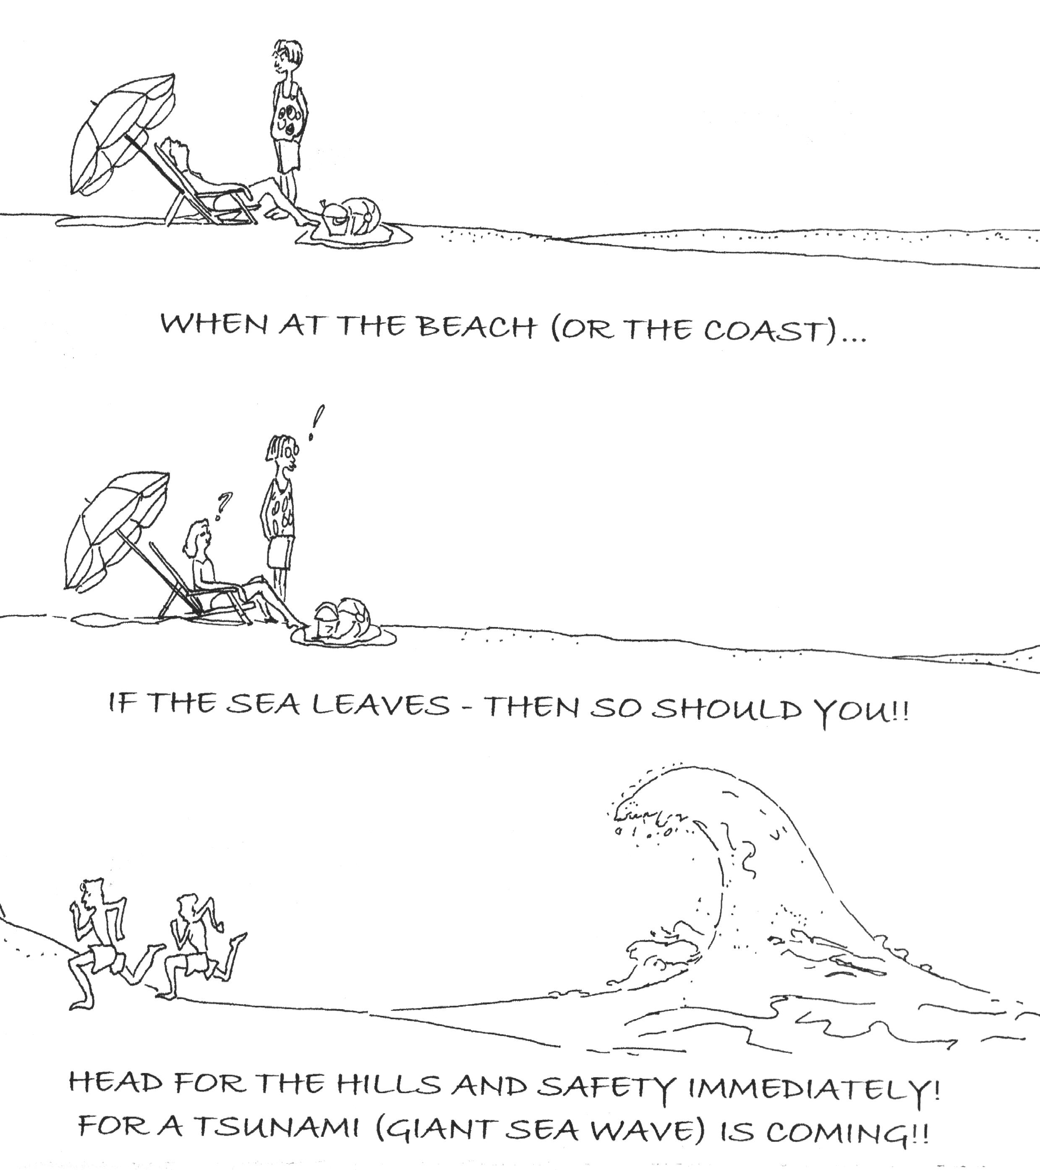
Sketch by Claudia Marquis-Wynette

Now that you have coloured the picture do you know?

What is a tsunami? ____________________

What would you do if you thought a tsunami was coming? ____________________

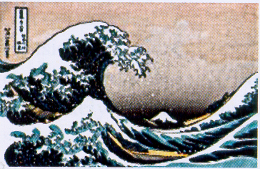

3
4
4
4
4
4
4
4
4
4
3
3
3
3
3
3
3
4
4
4
4
4
4
4
4
4
4
4
4
4
1
1
4
4
4
1
2
2
4
4
4
4
Answer
1 – A bomb / 2 – 9-1-1
CODE

1 – Red 2 – Brown
3 – Black 4 - Green

4
1 - What did you find? …………………………………………………….

2 - What number should you call if someone says you have one? ……….

4
Word find

B | C | R | A | T | E | R | E | A | S | H | E | S
F | P | R | R | E | S | C | U | E | D | O | M | E
L | I | N | S | T | R | U | M | E | N | T | S | W
A | C | T | I | V | E | W | A | V | E | P | E | A
S | E | P | A | M | A | G | M | A | R | E | V | R
H | E | A | R | E | D | I | A | C | D | A | I | N
L | A | V | A | H | E | A | T | U | F | K | L | O
I | R | O | B | S | E | R | V | A | T | O | R | Y
G | A | S | E | K | V | O | R | T | L | S | C | A
H | S | N | N | N | L | O | A | I | I | C | U | E
T | P | R | I | A | M | E | R | O | V | G | E | D
N | E | C | P | L | A | N | I | N | D | E | A | D
E | W | S | S | F | F | I | R | E | C | O | R | D
Reproduced with the kind permission of CDERA

Active
Air
Ashes
BSE
Caldera
Dead
Dome
Dust
Evacuation
Fire
Flanks
Flashlight
Gas
Heat

Hot

Instruments
Lava
Lives
Loa
Magma
Observatory
Peak
Plan
Record
Rescue
River
Spew
Spine
Warn
Wave

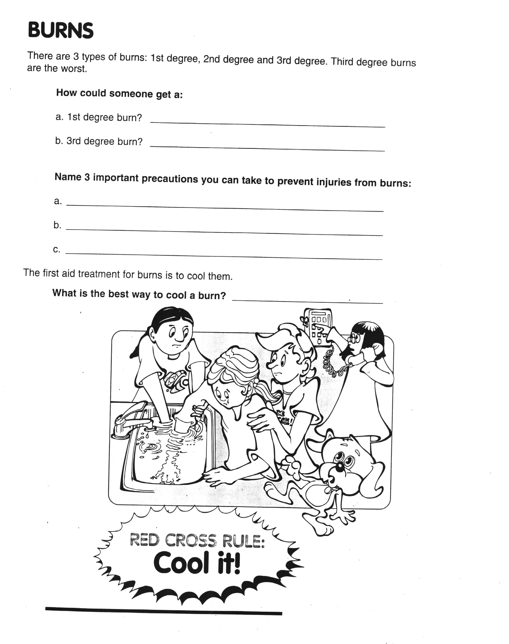
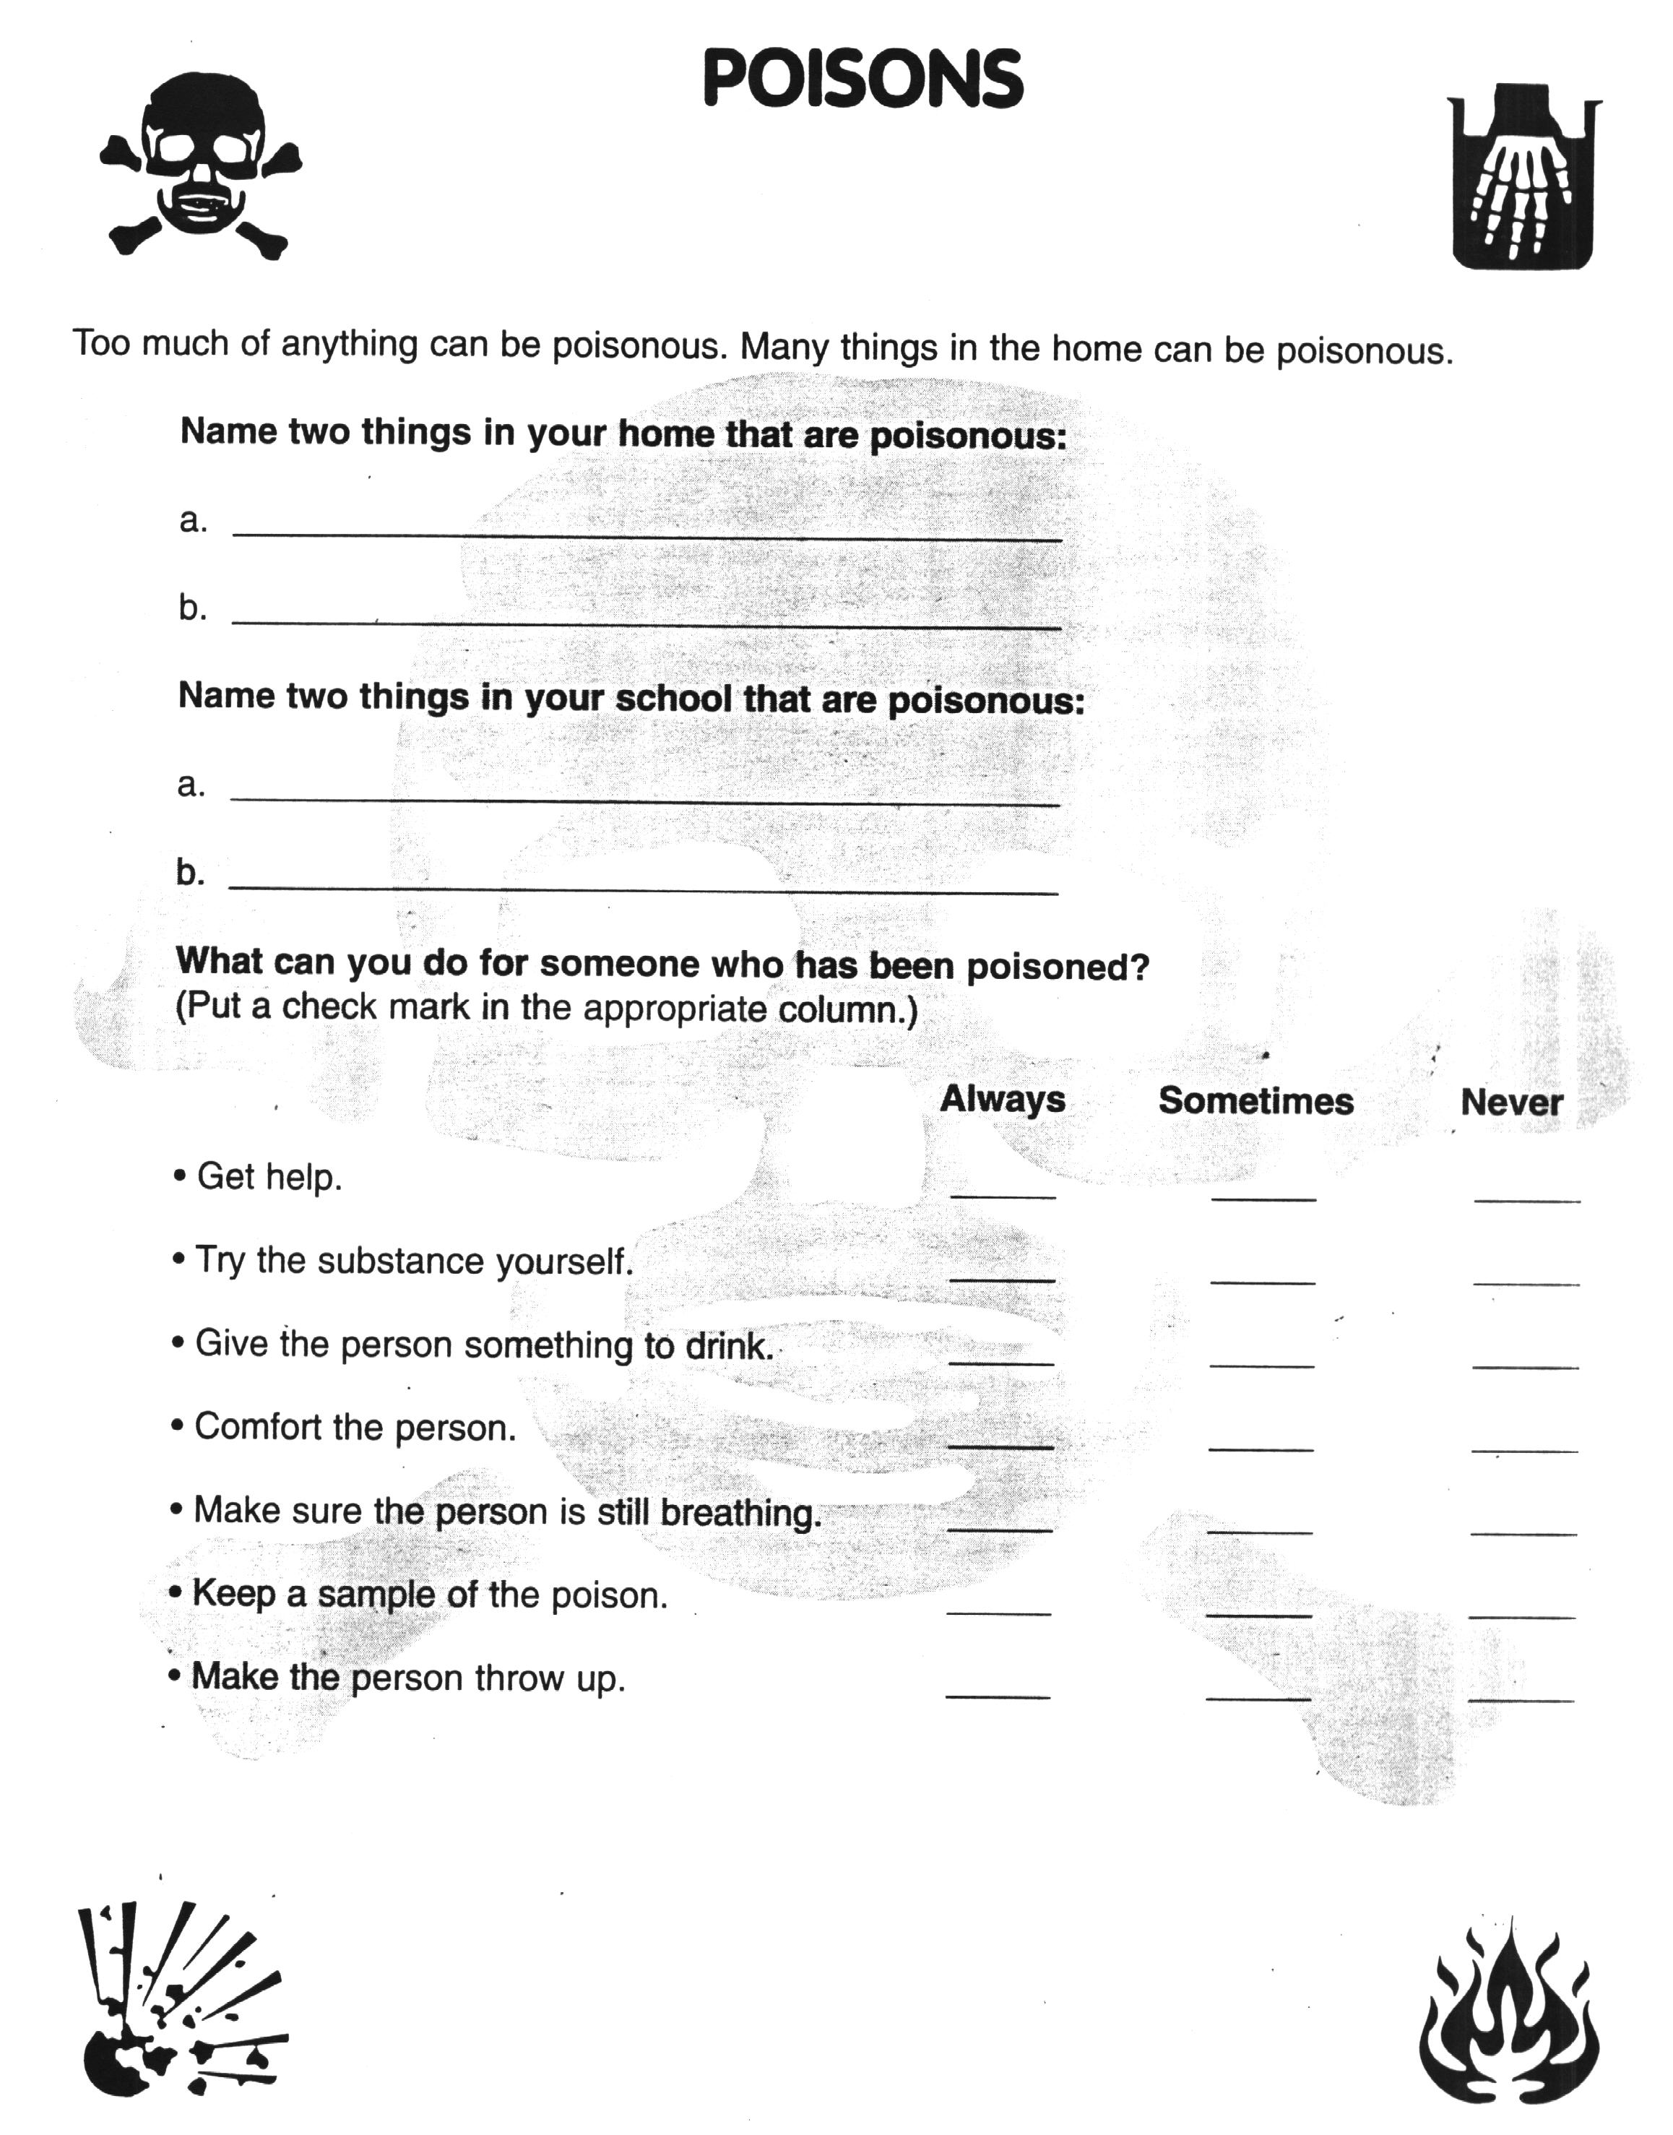
Colour the picture
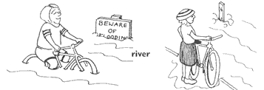
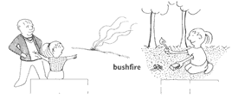
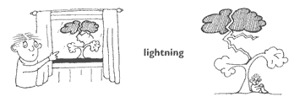
Pictures reproduced with the kind permission of
ODPEM - Jamaica

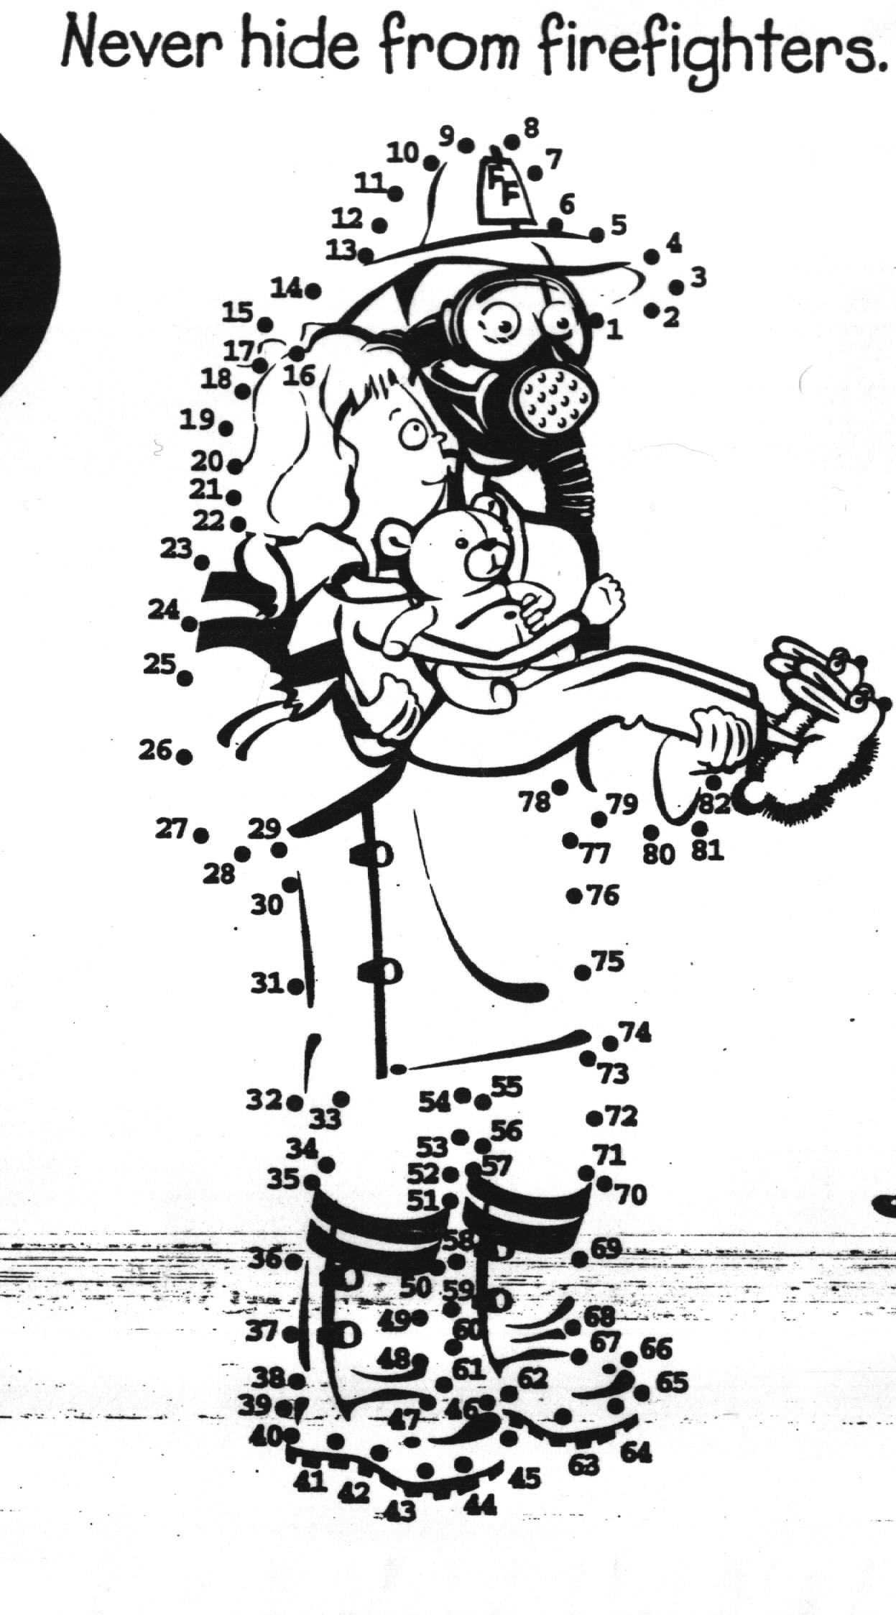
Join the dots...
Don’t be afraid of firefighters

In case of fire, they can help you escape
Produced with the kind permission of The US Fire Administration.
Quiz

The object is to unscramble the words to reveal the answer to the clue given. The clues themselves refer to actual phenomenon; can you guess what they are?

GTHGINNIL: - The bright flash in the sky when there is a storm is called?
_____________________________________________

OFDLO: - What happens when a river overflows its banks?
_____________________________________________

NCYLCEO: - What other name is a hurricane sometimes called?
_____________________________________________

LVAA: - What is the name of the substance that flows from an erupted volcano?
_____________________________________________

YEE: - What is the center of a hurricane called?
_____________________________________________

TUKAEQRAEH: - What natural disaster causes the earth to shake?
_____________________________________________

This quiz was reproduced with the kind permission of ODPEM
What do you know about fire hazards?
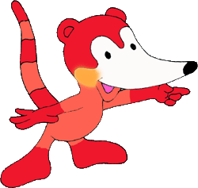
What is fire?

Fire is a chemical reaction between three elements: oxygen, heat and fuel. If any of the three elements disappear, the fire will disappear too. If conditions are right, a fire can start almost anywhere at any time. Most fire hazards occur when the weather is dry and hot.

The heat source for starting a fire in nature can be natural, for example a lightning strike, or human-made, like careless use of fire or even cigarettes. Fuels include anything from dry grass and leaves to branches, wood or - houses! Different types of fuel burn at different temperatures, because each substance has a so-called “ignition temperature”. This is when the substance becomes hot enough to burst into flames. For example, because of its low ignition temperature, the oil in the leaves of eucalyptus trees is one of the most explosive fuels that exist in nature.

What can you do to protect yourself and your friends from fires?
If a dangerous fire comes close to you:
- Don't panic
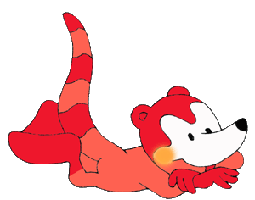
- Move away from the fire
- Ask adults for a safe house to protect you from the flames

If thick smoke makes breathing difficult
- Cover your mouth with a dry handkerchief
- Ask adults for a safe house to protect you from the smoke

If your clothes catch on fire:
- Don't panic
- Move away from the fire
- Drop to the ground and cover your face
- Roll over and over until the fire is out

If a friend of yours or one of your family members is on fire:
- Wrap them in a blanket
- Roll them over on the ground until the fire is out

Test your knowledge on fires!


Questions:

- What are the three elements needed for a fire?

- What does “ignition temperature” mean?

- If your clothes catch on fire, what should you do?

My Grade: ______________________________________

This document was prepared by the Secretariat for the International Strategy for Disaster Reduction (ISDR), with the assistance of the Global Fire Monitoring Center (GFMC), Freiburg, Germany (http://www.uni-freiburg.de/fireglobe). Reproduction of this document in part or in whole for non-commercial educational purposes is encouraged.

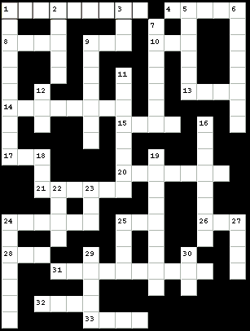

Across
1 across -- The National ____ Management Organisation
4 across -- A natural disaster involving very high water
8 across -- An important evacuation route
9 across -- Where you take a bath
10 across -- A ____ of sunshine
13 across -- ____ and pepper
14 across -- It can keep the rain off you
15 across -- What you do with gum
17 across -- A hurricane swirls around an: ____
20 across -- A funnel cloud
21 across -- Urban search and ____
24 across -- Hurricane ____ runs from June to November
25 across -- All families need a Disaster Supply ____ with food, water and other items
26 across -- NEMO works with the Saint Lucia ____ Cross to help people in a disaster
28 across -- A long, flat fish
31 across -- This word means to reduce risk to your home from a disaster
32 across -- The federal agency that helps people during a disaster (abbreviation)
33 across -- All families need a Disaster ____ so you'll know what to do
Down
1 down -- A disaster caused by the ground shaking
2 down -- An important part of your disaster kit: a battery-powered ____
3 down -- Corn on the ____
5 down -- When it's cold, dress in ____
6 down -- All homes need a smoke ____
7 down -- It is important to ____ for disasters
9 down -- Another name for an earthquake
11 down -- If a disaster comes, you may be asked to ____ (leave your home)
12 down -- The shortened first name of President Lincoln
16 down -- A fire that sweeps through prairies, forests or other wide open areas is called a: ____
18 down -- Listen for a tornado with your ____
19 down -- When it's cold outside, you have to be careful about ____
22 down -- Being a Disaster Action Kid isn't ____
23 down -- Disasters happen, but people ____ prepare
24 down -- When you evacuate, you may stay in a ____
25 down -- The husband of a queen
27 down -- In an earthquake, ____ and cover
29 down -- You should ____ your waterheater to the wall
30 down -- If you evacuate, take your pet with ____

Reproduced by NEMO with the kind permission of FEMA

Answers/Poisons:

1A: Bleach, Gas
1B: Medications.
2A Ink, Lab Chemicals
3: Always, Never, Never, Always, Always, Always, Never

Answers/Burns:

1A: Hot Liquid (Water, Coffee etc.) 1B: Chemical (acid).
2A: Secure matches, lamps, candles, etc.
2B: Stay away from harmful chemicals
2C: Do not play with fire.
3: Apply cool running water.

Answers (Fire):

1. Oxygen, fuel and heat.
2. “Ignition temperature” is the temperature at which the preheated substance will burst into flames.
3. Do not panic. Move away from the fire. Drop to the ground and cover your face. Roll over and over until the fire is out.
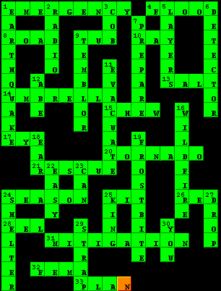

This funbook was produced by the
Saint Lucia National Emergency Management Office.
452-3802

Some parts were used with the permission of:
The Saint Lucia Red Cross Society
The Office of Disaster Preparedness and Emergency Management (ODPEM) – Jamaica
The Caribbean Disaster Emergency Response Agency (CDERA)
The US Fire Administration
The Secretariat for the International Strategy for Disaster Reduction (ISDR)
The Federal Emergency Management Agency (FEMA)

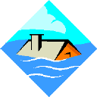
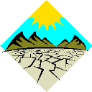
Flood or Drought
Rain or Shine
CALL THE
SAINT LUCIA WEATHER HOTLINE
454-3452

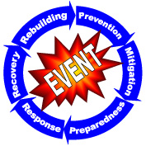
The NEMO Workbook

