
Government of Saint Lucia

National Response Forms
Document of the Saint Lucia National Emergency Management Plan

Approved under various Response Plans by
[NEMAC]

[Date of Approval]

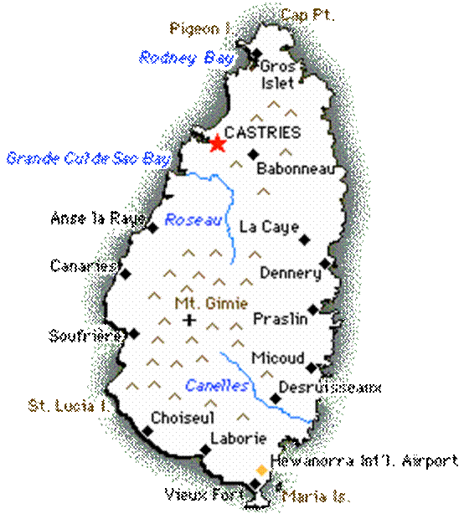
TABLE OF CONTENTS

Request for Activation of the National Response Mechanism 4
Message Form 5
Delivery Form 6
Vehicle Release Form 7
Vehicle Request Form 9
Vehicle Return Form 10
APPLICATION FOR DISASTER ASSISTANCE 11
NEMO Community Complaints Report Form 13

Request for Activation of the National Response Mechanism

SITUATION REPORT Add addition pages if needed

1. DATE: TIME:

2. LOCATION OF EVENT:

3. NUMBERS INVOLVED:

3A. DEATHS…………….. INJURIES……………. MISSING…………….

4. RESPONSE ACTIONS TAKEN:
(Since last report)

5. PERSONNEL, EQUIPMENT ON SCENE

6. AREA /BUILDINGS THEATENED [IF ANY]:

7. THREAT OF HAZARDOUS MATERIALS [IF ANY]:

8. NEED FOR EVACUATION (Y) (N)

8A. APPROXIMATE NO. OF PERSONS:

9. SPECIAL POPULATION NEEDS:

10. ADDITIONAL RESOURCES NEEDED IN PRIORITY ORDER:

12. COMMENTS on need for activating NEOC

SGD.…………………………………… DATE……………….. TIME…………
ON-SCENE COMMANDER

NEMO Fax: 453-2152

Message Form
Disaster Event: __________________________

To: | Method of Communication: | From:

Date of Message | Time of Message

CONTENT:

ACTION TAKEN:

Delivery Form

SAINT LUCIA

NATIONAL EMERGENCY MANAGEMENT ORGANIZATION

TO [Agency]: ………………………………

ITEM PROVIDED

CATEGORY | NAME OF ITEM | QUANTITY REQUIRED | QUANTIFY SUPPLIED

Requesting Officer …………………… Agency ……………………………… Date ………….…

Supplying Center ……………………. Supplying Officer …………………. Date ………........

Received by…………………………... Date…………………………. Time………………….......

Vehicle No………………………………..

Checked by……………………………………………

Checked by …………………………………………. (Supply manager)

Checked by ………………………………………….. (Driver)

Auto Inspection Form

Date: (DD/MM/YYYY) __ __ /__ __ / 20__ __ Time: ____________hrs (e.g:1350hrs)
Receiving Officer __________________ Delivering Officer ___________________
Vehicle Reg. # SLG _______ Vehicle Mileage __________ Fuel Level _______
Loaning Government Department _____________________________
Agency/Department Re-assigned to _____________________
Vehicle: Make/Model/Year _______________/ _________________/ __________________
Indicate below all existing damage including; dents, chips, scratches, holes, rust, etc.
Give special attention to paint, fenders, and all bumpers.

EXAMPLE: Indicate with circle around area of damage and check box(es) which best identify damaged area. If there is no visible damage please so state.

Chipped or broken glass _____ Bumper (rear) _____ Fender skirts_____
Scratch _____ Trunk_____ Side moulding_____
Dent _____ Hood-Grill _____ Windshield_____
Missing hubcap(s) _____ Top_____ Rear window_____
Faded Paint _____ Right side _____ Side glass_____
Bumper (front) _____ Left side_____ Tires_____

There is no existing damage to this vehicle__________

Remarks____________________________________________________________________________________________________________________________________________

* I have visually inspected this vehicle _________________________

Date Inspected_________________ Inspector’s Signature_____________________

Delivering Officer’s Signature____________________ Date___________________

Vehicle Release Form

National Emergency Management Organisation
Prime Minister’s Office

Telephone (758) 452-3802 / 468-2126 | P O Box 1517
Fax (758) 453-2152 | Bisee
Telex 0398 6272 LC | Castries
E-mail admin@nemo.gov.lc | Saint Lucia, West Indies

URL: http://nemo.gov.lc
Date: ______________
To: Control Officer - Coordination Centre

NEMO Secretariat hereby authorizes the release of a vehicle from the Coordination Center.

Name of Driver: |  | Driver’s License No.
Signature of Driver:
Agency/Committee taking Vehicle
Type and License Number of Vehicle Assigned
Date and Time of Release:

Expected Date and Time of Return
Actual Date and Time of Return:
Name, Rank and Number of Control Officer:

…………………………..
Velda Joseph (Mrs.)
Director – NEMO

Vehicle Request Form

Saint Lucia
National Emergency Management Organisation Secretariat

From : Director NEMO

TO : ________

DATE : ________

----------------------------------------------------------------------------------------------------------------------------
SUBJECT : REQUEST FOR TRANSPORTATION
=========================================================================

Grateful if SLG ______________________ would be made available to the NEMO Secretariat to facilitate an Emergency Response.

DATES REQUIRED
PROJECT
DRIVER
FUEL REQUIRED | [ ] YES [ ] NO
CLEAN INSIDE | [ ] YES [ ] NO
CLEAN OUTSIDE | [ ] YES [ ] NO
TYRES CONDITION | [ ] NEW [ ] IN NEED OF AIR [ ] BALD
OFFICER [ISSUING]

Thank you, for your kind cooperation

…………………………..
Velda Joseph (Mrs.)
Director – NEMO

Vehicle Return Form

Saint Lucia
National Emergency Management Organisation Secretariat

From : Director NEMO

TO : ________

DATE : ________

----------------------------------------------------------------------------------------------------------------------------
SUBJECT : RETURN OF TRANSPORTATION
=========================================================================

Thank you for the use of SLG ______________________ by the NEMO Secretariat to facilitate an Emergency Response.

DATE RETURNED
PROJECT
DRIVER
FUEL REQUIRED | [ ] YES [ ] NO
CLEAN INSIDE | [ ] YES [ ] NO
CLEAN OUTSIDE | [ ] YES [ ] NO
TYRES CONDITION | [ ] NEW [ ] IN NEED OF AIR [ ] BALD
OFFICER [RECEIVING]

Thank you, for your kind cooperation

…………………………..
Velda Joseph (Mrs.)
Director – NEMO

APPLICATION FOR DISASTER NON COMMERCIAL ASSISTANCE
Application
No.
_____________
Based on the Turks and Ciaos Islands Assistance Form of 2008
Page 1 of 3

NATURE OF INCIDENT
NAME OF APPLICANT AND ID NUMBER/TYPE OF ID:
LOCATION OF IMPACTED SITE:

APPLICATION DATE [DD/MM/YY]: ........../........../...........

CONTACT INFORMATION | FAMILY INFORMATION  NUMBER OF PEOPLE IN FAMILY?  - NO. OF CHILDREN?  - NO. OF OLDER PERSONS?  - NO. OF DISABLED?  - Type of disability?  [PTO FOR DETAILS] | TYPE OF OCCUPANCY  RENTAL [ ] OWNER [ ]  OTHER [ ]
TELEPHONE NO. |  | EMPLOYED? Y [ ] N [ ]  SELF-EMPLOYED? Y [ ] N [ ]
FAX NO. |  | ARE YOU INSURED? Y [ ] N [ ]  TYPE OF INSURANCE  - BUILDING [ ]  - CONTENTS [ ]
eMAIL:

NAME OF OWNER: ...........................................................................................................

DESCRIPTION OF DAMAGE [use additional paper if needed]
KITCHEN: stove [ ] fridge [ ] freezer [ ] pots n pans [ ]
BEDROOM: bed [ ] wardrobe [ ]
LIVING ROOM: living room suite [ ] TV [ ]
DINING ROOM: dining room suite [ ]
STUDY: Office desk and Chair [ ]
OTHER
Application
No.
_____________

Page 2 of 3
Family Information:

No. | Name | Age | Disability  [if applicable] | Which school attending  [if applicable] | ID No. and Type

Declaration of truth:

I certify that the information above is correct and true.

..........................................................................  Applicant  Date: [DD/MM/YY]: ........../........../........... | ...........................................................................  Chair – District Disaster Committee  Date: [DD/MM/YY]: ........../........../...........

Application
No.
_____________
For Official Use

Page 3 of 3

Block and Parcel No. of Location:

ASSISTANCE RECOMMENDED | ESTIMATE [EC$]

NEMO Community Complaints Report Form

Complainant: ..............................................................................................................................................

Address: .....................................................................................................................................................

Telephone: ......................................... [h] ................................................ [w] ................................... [m]

Report Date: ........................................................... Time: .........................................................................

Location of Issue: .......................................................................................................................................

Description:

.....................................................................................................................................................................

.....................................................................................................................................................................

.....................................................................................................................................................................

Plaintiff: ......................................................................................................................................................

Address: ......................................................................................................................................................

Telephone: ........................................... [h] ...................................... [w] ............................................ [m]

Suggestions/Recommendations:

.....................................................................................................................................................................

.....................................................................................................................................................................

.....................................................................................................................................................................

Notes

.....................................................................................................................................................................

.....................................................................................................................................................................

.....................................................................................................................................................................

Signed: .......................................................................................

Storm/Hurricane: Hurricane Tomas

Date: 31 October, 2010

Time: 5:00am

Coordinates: 14.0 North | 62.9 West

Miles away from SLU: 130 W

Sustained Winds: 100 MPH

Moving: WNW AT 8 MPH

TS WARNING FOR SLU
NEMO Sign up form

Name
Address
Company Name (if applicable):
District
Telephone No. | Work:
Telephone No. | Home:
Telephone No. | Cell:
Fax No.
Email
My Skills
Equipment/Tools which I can make available:
Other relevant information about myself:
I am over 18 years of age | [ ] Yes [ ] No
Date of submission

