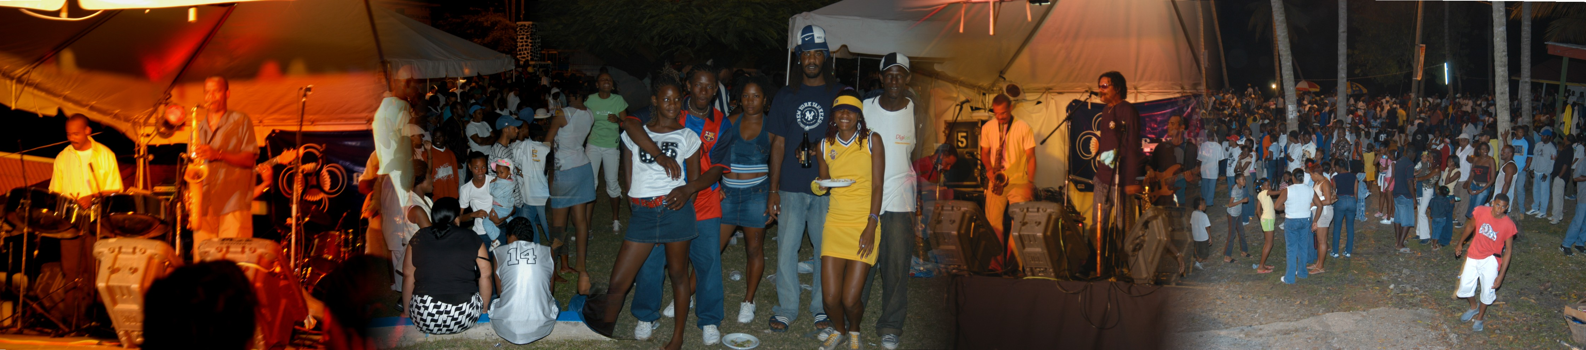
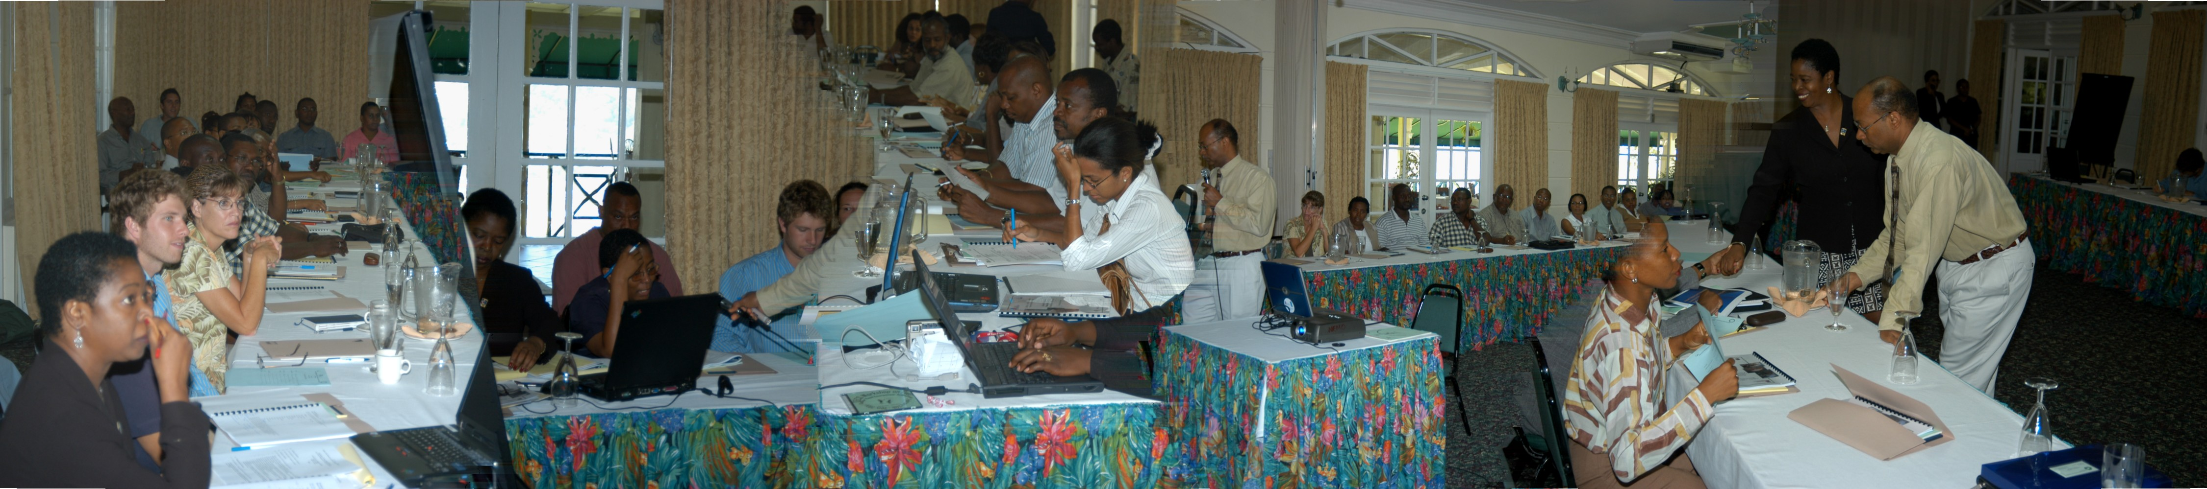
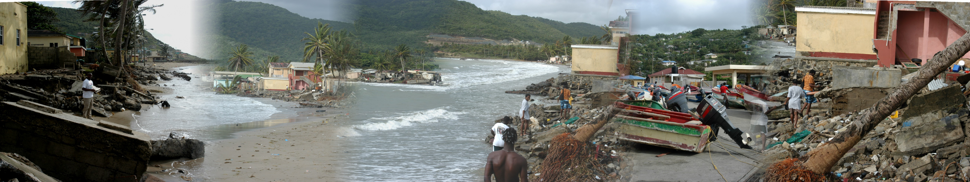
CALYPSO
HURRICANE IVAN DENNRY
HAZARD MAPPING & VULNARABILITY ASSESSMENT WORKSHP
FAMILY DISASTER PLAN

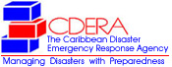 Family Plan
First Name:
Last Name:
Email Address:
Where will we go if we have to evacuate? (Name, Address, Tel #):
Have I made appropriate arrangements?: | Yes  No
Have I notified my family/friends of our plans?: | Yes  No
If the answer to the above is yes, list the names, addresses, and telephone numbers of those people who were notified:
Does my employer provide a special shelter for me and my family?: | Yes  No
If the answer to the above question is yes, list the name, address, and telephone number of the shelter:
Name and type of pets:
What will I do with my pets if I stay home?:
What will I do with my pets if I shelter elsewhere?:
Do I have a boat?: | Yes  No
How will I secure that boat?:
If I stay home, what preventative measures will I take to safeguard my home and my life?:
Windows/glass door protection purchased?: | Shutters  Plywood (1/2 inch or thicker)  None purchases as yet  I already have shutters and/or material
Have important papers been copied and secured as well as valuables? If so, where are they located?: | Yes  No  I have no valuables or important papers (sure?)
If the answer is yes, list the location:
Has a safe room been identified?: | Yes  No
Do I have a survival kit?: | Yes  No
Write down all important names, addresses, phone numbers, account numbers, policy numbers etc of doctors, insurance agents (health, car, home), lawyers, family and friends:
Bottom of Form

EMERGENCY NUMBERS:

POLICE | 9-9-9 | SPOUSE
FIRE AMBULANCE | 9-9-9
DOCTOR
HOSPITAL
VET
