YOUR BUSINESS LOGO HERE
[If applicable]

CONTINUITY OF OPERATIONS PLAN
for

_________________________________________
YOUR BUSINESS NAME HERE

_________________________________________

DATE OF PLAN HERE

Developed by the Saint Lucia National Emergency Management Organisation Secretariat and

Modeled upon CDERA Family Disaster Plan at

http://www.cdera.org/doccentre/familyplan.html

In collaboration with NEMO Secretariat

[Date of Approval]

BUSINESS DETAILS

Business Name:
Location:
First Name:
Last Name:
Email Address:
Where will we go if we have to evacuate?
(Name, Address, Tel #):
Have I made appropriate arrangements?: | [ ] Yes  [ ] No
Have I notified my family/friends of our plans?: | [ ] Yes  [ ] No
If the answer to the above is yes, list the names, addresses, and telephone numbers of those people who were notified:
Do we provide a special shelter for me and my staff?: | [ ] Yes  [ ] No
If the answer to the above question is yes, list the name, address, and telephone number of the shelter:
Do I have a boat?: | [ ] Yes  [ ] No
How will I secure that boat?:

If I stay home, what preventative measures will I take to safeguard my home, my business and my life?:
Windows/glass door protection purchased?: | [ ] Shutters  [ ] Plywood [1/2 inch or thicker]  [ ] No purchases as yet  [ ] I already have shutters and/or material
Have important papers been copied and secured as well as valuables? | [ ] Yes  [ ] No  [ ] I have no valuables or important papers (sure?)
If yes, where are they located?:
Has a safe room been identified?: | [ ] Yes  [ ] No
Do I have a survival kit?: | [ ] Yes  [ ] No
Write down all important names, addresses, phone numbers, account numbers, policy numbers etc of doctors, insurance agents (health, car, home), lawyers, family and friends:

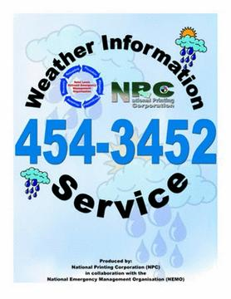

STATISTICS

Of the five business affected by Tropical Storm Debbie; three 3 never reopened for business

