**Saint Lucia**

**Red Cross Society**

**Community Risk Reduction**



**Healthier, Safer Communities**

BELAIR

(New Development)

**VULNERABILITY AND CAPACITY ASSESSMENT**

***May 2011***

# Acknowledgements

The St. Lucia Red Cross along with the team of dedicated members from the community of Belair would like to express their deepest gratitude to the many persons and institutions who made this document a reality. To the residence and young at heart who made the effort every Monday night to be present at the Belair Community Center under the motivation of Ms. Nelira Alexander, we thank you wholeheartedly.

To the Red Cross volunteers, NIT members who participated in undertaking the baseline surveys which paved the way forward for this document and the future of the community, thanks for the support. Without a venue the nightly session would have been difficult to conduct and for that we thank Ms. Matilda Yarde who ensured the Human Resource Center was always available for such an initiative.

The support given by the government statistic department in making available the secondary data on the community was critical in analysis the outcome of the VCA and we would surely like to thank you for the information and your kind assistance.

To the community members of Belair who took time to answer the baseline survey questions and those who cooperated in welcoming the Red Cross members and other community members into their homes and business places to complete the family emergency plans, your efforts and energies is a reflection of the willingness of Belair to be a more resilient community.

.

# Table of Contents

**Abstract …………………………………………………………………………………………..4**

**Foreword …………………………………………………………………………………………5**

**Introduction ……………………………………………………………………………………...6**

**Part 1 : Vulnerability and Capacity Assessment of Belair ……………………………………7**

What is a VCA ? …………………………………………………………………………..7

How is the VCA carried out ? ……………………………………………………………..8

1. Gathering data from secondary sources …………………………………………………..9
2. Direct observation ……………………………………………………………………10-11
3. Focus group discussion ………………………………………………………………12-20

**Part 2 : Risk Assessment in Belair …………………………………………………………….21**

Methodology for a Risk assessment ……………………………………………………………..21

1. Identifying hazards and their potential impact on the community …………………...22-23
2. Local capacity to respond to hazards……………………………………………………..24
3. Types of measures to mitigate hazards ………………………………………………25-26
4. Ability to act on hazards (CIA/T analysis) …………………………………………..27-28

Conclusion: The next steps……………………………………………………………………..31

# Annex 1: List of participants in the Vulnerability and Capacity Assessment……………...30

# Abstract

Five months have passed since the commencement of the initiative to develop a CDRT in Belair while embarking on a data collection process to prepare a VCA report. Though a few community members were the ones who approached the National Society to undertake the project, its importance was not initially mutual throughout the community. However community sensitization sessions along with Hurricane Tomas relief operations created the environment for acceptance of the project and its overall objectives.

As a platform to launch the VCA data collection session a Community Based First Aid session was conducted with participants and focused on basic techniques dealing with Check-Call-Care, stopping of bleeding wounds, treating burns, adult and infant CPR including how to assist a choking victim. An HIV and AID education component was also added to further enhance the community’s resilience.

Participants were introduced very early to the mapping exercise along with the Historical Calender so as to gain an appreciation of the community and to foster a team spirit. The exploring of the community to draw the spatial map and source information on the short history of Belair proved to be an educational experience ,especially when the transect walk was conducted which revealed some negative street names.

Exploring the social and institutional networks of the community was an activity which focused on highlighting the social relationships in Belair.

The make-up of the VCA data collection team proved to be well balanced comprising of older persons, young women, various church and community organization representatives and a few men. This allowed for a wide and varied view on the data in accessing the information to put in the VCA.

**Foreword**

The present VCA study was carried out through a series of community meetings commencing in January of 2011 and concluding in May 2011 with the Belair community.

This study is part of the International Federation of Red Cross and Red Crescent Societies (IFRC) regional project “Improving the preparedness of Caribbean communities to respond to disasters affecting their locality”. This program, implemented in 2009-20011, covers the National Societies of Trinidad & Tobago, Surinam, Bahamas, Antigua, St. Kitts, Barbados, St. Vincent , Guyana and Saint Lucia, through the support of the European Commission Office for Humanitarian Aid (ECHO) and the United States Office for Disaster Assistance (OFDA).

# Acronyms

CIA Change / Influence / Accept

CIT Change / Influence / Transform

ECHO European Commission Office for Humanitarian Aid

IFRC International Federation of Red Cross and Red Crescent Societies

OFDA United States Office for Disaster Assistance

VCA Vulnerability and Capacity Assessment

NEMO National Emergency and Management Organisation

SLURC St. Lucia Red Cross

CDRT Community Disaster Response Team

NIT National Intervention Team

# Introduction

In January 2011, the rural Castries community of Belair embarked on a journey of self-analysis, examining its strengths and weaknesses, the external and internal threats and the resources it has to cope with these threats. Heads of households, local leaders of religious and sports groups, workers of all trades especially the women of the community and other concerned members, discussed the history of their community and the problems they encounter. They shared their experiences and their tips for overcoming daily difficulties. As a group, they identified the main problems ahead and discussed the future of their common home.

During the collection of the VCA data the community along with the rest of Saint Lucia was impacted by Hurricane Tomas causing landslides and flooding which affected homes and banana farms. This disaster fueled the concerned of Belair residents to approach the Red Cross and commence the Readiness to Respond initiative.

Past and recent experiences such as the flooding caused Tropical Storm Debbie (1994) and Hurricane Tomas (2010) laid the foundation for the early acceptance of the project at the community level. With a population of 291 with a household population of 70, the community can be described predominantly as a farming community being beneficiaries of a relocation project from the farming community of Tete Chemin in 1997.

The isolated nature and the absence of a number of social amenities make Belair a most vulnerable community.

The process was organized by volunteers and staff of the St. Lucia Red Cross Society (SLURC), along with other community members as part of a region-wide attempt to improve community-based disaster preparedness. The community work was based on the methodology known as “Vulnerability and Capacity Assessment”, or VCA. The purpose of this assessment is to identify and understand the most pressing issues and threats in the community (vulnerabilities) while simultaneously identifying the local and external resources available to minimize the risks to the villagers (capacity).

The VCA approach is composed of a series of tools for community-based participatory consultations to ensure a better understanding of how the community functions. Behind this process lies the assumption that a community more aware of its own limitations can organize itself better to overcome them. In the context of the SLURC project, the stated objective was to improve the capacity of the community to cope with the disaster-related risks in its environment.

To this end, the first section summarizes the results from the VCA process, as carried out in Belair . It presents the history, the local dynamics and the coming challenges, as perceived by the people who live in Belair. Although this program explicitly focuses on natural disasters and hazard mitigation strategies, the results presented in this first section provide guidelines for a broader approach towards sustainable community development.

The second section focuses on the output from the community focus groups in relation to the risks faced by the community: Which are the main risks? Can they be mitigated? By whom? Using the results presented in the proposed Action Plan, the community members – supported by SLURC teams – will identify and implement strategies to mitigate these risks. The information gathered here will also provide the necessary baseline information for monitoring and evaluation the progress of the community.

1 Quoted from the *St. Lucia 2010 Housing and Population Census*

Part 1: Vulnerability and Capacity Assessment of Belair

### What is VCA?

Vulnerability and Capacity Assessment (VCA) is a participatory investigative process designed to assess the risks that people face in their locality, their vulnerability to those risks, and the capacities they possess to cope with a hazard and recover from it when it strikes. Through VCA, National Societies can work with vulnerable communities to identify the risks and take steps to reduce them by drawing on their own skills, knowledge and initiative. **In sum, VCA helps people to prepare for hazards, to prevent them from turning into disasters and to mitigate their effects**.[1]

***Vulnerability*** *can be defined as:*

*The characteristics of a person or group in terms of their capacity to anticipate, cope with, resist and recover from the impact of natural or man-made hazards****.***

The definition of vulnerability suggests that it cannot be described without reference to a specific hazard or shock. So, the question that must always be asked is, ''Vulnerability to what?" People living along coastal areas or rivers may be vulnerable to seasonal storms and flooding, while the inhabitants of countries with social, political and economic problems may face difficulties in achieving a satisfactory and sustainable quality of life.

*The reverse of vulnerability is* ***capacity****, which can be described as:*

*The resources of individuals, households, communities, institutions and nations to resist the impact of a hazard.*

The coping strategies of people in response to various hazards will differ from one society to another and will often change over time. People in chronically-prone countries facing multiple hazards, such as drought, locust infestation and civil unrest, find their capacity levels weakening, reducing their ability to mitigate the effects of the next crisis.[2]

### How is the VCA carried out?

The VCA process relies on a few key principles:

**Data collection:** Preliminary data can be collected through the use of questionnaires, developed specifically for each community or for each type of hazard. However, as information is not always immediately available on the ground – because of time constraints, security issues or financial resources – the VCA process also relies on the gathering of secondary data. Precious information about the community can be gathered from research by government bodies, the United Nations and other development- and research-based organizations.

**Community participation:** The goal of the VCA process is to empower the community to allow it to respond on its own to the risks to which it is subjected – or allow it to identify those who can help it to respond. For this reason, community members constitute the core of the process. The main criterion for a successful VCA is the receptiveness of the local community and its willingness to be an active part of the process. Only if all vulnerable groups are included, can they find collective answers to the threats they face.

**Sharing information:** The VCA process helps the community understand its relation to its environment. Through discussions among neighbors and the collection of data, the community members will be better able to understand – and therefore reduce – the threats to which it is subjected. The final VCA document also offers an opportunity to share information beyond the community, by bringing up issues to the relevant authorities, partner organizations or local leaders.

The VCA is mainly used ***to identify in advance, and change where possible, the conditions that create or contribute to the state of vulnerability of at-risk populations***.[3] As such, the main usefulness of VCA comes from an improved understanding of the risks and of measures to mitigate that risk. To gather all information relevant to a better understanding of the community, the following steps have been followed:

1. Review of secondary sources: this first, crucial, step consists in collecting information that already exists, to avoid duplicating efforts already carried out. Most of this phase consists in collecting written material, or identifying all resources relating to a better understanding of the community;
2. Direct observation: A summary presentation of the community, by someone external, often allows to get a first impression of the local dynamics and main issues;
3. Focus group discussions: The heart of the VCA process lies in this phase of community interaction, using tools for the involvement of all stakeholders.

Based on these three steps (presented hereafter in points 1, 2 and 3), disaster-related information has been gathered and is presented in part 2.

## Gathering data from secondary sources

### Location of the community

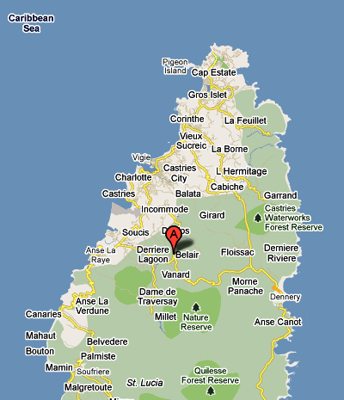Belair is located in the central section of the island about 11Km or just 18 minutes drive from the Capital City Castries.

Coordinates: 130 94’ 69.21” N 600 97’ 79.12” W

### 

### Population of Belair (New Development)

291 Persons / Household Population: 70

The entire community of Old Belair and New Belair has a population of 541 persons (2010Census)

### Community map

### 

## Direct observation

This rural community located in the central section of Saint Lucia is a farming community bordered by the communities of Sarrot and Millet. The community is about 14 years old as a result of a relocation project of persons from the neighbouring community of Millet. The very short history of this community and isolated nature makes it’s a community lacking a number of social amenities thereby increasing the vulnerability. The following are some key areas of observation in Belair.

|  |  |
| --- | --- |
| ***Demographics*** | ***Health, Sanitation & Essential Services*** |
| * The community has a population of 291 persons with a household population of 70 and an average family size of 3 * Gender breakdown: Males- 150 / Females- 141; * More than 40% of the population are between the ages of 0-35 reflecting a high percentage of young person * An unemployment population of 16.5% predominantly among young persons * While there is a high presence of extended families households are predominantly nuclear families with 1 to 2 children; | * While there is a Human resource Center no other social amenities exist; * There are no schools, day care services, churches, Heath centers, Post offices or police station; * These essential services are accessed in the community of Bexon, Marigot or the Capital city of Castries * A proper garbage collection system exit throughout the community; * Pipe borne water exist within the community and most persons access water from their homes; * While there are septic systems in the community there is the absence of a sewer system and a presence of pit latrines in some sections * Electricity is available throughout the community with most areas having the presence of electrical lamp except for some which render major darkness. * Landlines (telephone) are widely available in the community however mobile phones have become the predominant mode of communication; * The community is about 18 minutes drive from the city of Castries and is serviced by Police, emergency fire and medical services from the city. |
| ***Daily Activities*** | ***Visible Vulnerabilities and Capacities*** |
| * The elderly persons are mostly engaged in farming as the main economic activities; * Recreational activities of adults tend to stem around the playing of dominoes and watching television * A high level of gambling takes place at the community shop along with free style singing by young men * Two major Christian denominations form part of the community, namely Catholic, Seventh Day Adventist. * The Human Resource Center serves as the main area for social activities in the community; * The presence of a field and a makeshift basketball court serves as the areas of recreation for young the young men * The recent upgrading and fencing of the Primary School’s field provides an added recreational facility for students; * Most persons in the community utilize the public transportation system and there is a small population of persons with their private vehicles | ***Vulnerabilitie****s*   * The proximity of a number of homes to the road and river * Absence of lighting along some areas in the community * The presence of the river running along side the community and next to farms * Erosion along the elevated areas in the community * Land Slippage prone areas especially in the upper section * Presence of an unpaved road and gravel along the road in Belair. * Large areas of bush which may tend to encourage rodents and stagnant water * Stagnant water along drains which are close to homes   ***Capacities***   * Availability of small community shops * Farmland and crops; * Playing Field and Human Resource Center * River * Human resources (teachers, police officers, mechanics, heavy equipment operators, farmers, construction workers, etc.) * Heavy equipment, minibuses |

## Focus group discussions

***A focus group discussion is a qualitative information-gathering tool whereby a group of selected individuals, guided by a facilitator, are invited to give their thoughts and views on a specific issue***.[4] To facilitate the process of interaction with key community stakeholders, the International Federation has developed a series of tools for participatory appraisals. These include, but are not limited to:

1. Historical profile;
2. Historical visualization;
3. Seasonal calendar;
4. Institutional and social network analysis;
5. Livelihoods and coping strategies analysis;
6. Mapping;
7. Transect walk;
8. Household/neighborhood vulnerability assessment;
9. Assessing the capacity of people’s organizations;
10. Venn diagram.

Not all tools are used every time, nor are these tools the only ones used to encourage community mobilization. More than the tools, the success of the VCA is measured by the mobilization it induces within the targeted community.

### Historical profile

|  |  |
| --- | --- |
| **Year** | **Activity** |
| **1985** | First Residence move into Belair |
| **1997** | Development and construction of Roads |
|  | Installation of utility poles |
|  | Installation of Fire Hydrants |
|  | Construction of Human Resource Center |
|  | Relocation of tet-chemin residence to Belair |
| **2011** | Establishment of CDRT |
|  |  |

### Historical Pictogram

|  |  |  |  |  |  |
| --- | --- | --- | --- | --- | --- |
| **YEAR** | **Population** | **Trees** | **Roads** | **Farms** | **Houses** |
| **1985** |  |  |  |  |  |
| **1997** |  |  |  |  |  |
| **2005** |  |  |  |  |  |
| **2011** |  |  |  |  |  |

### Seasonal calendar – Belair (Social activities)

|  |  |  |  |  |  |  |  |  |  |  |  |  |
| --- | --- | --- | --- | --- | --- | --- | --- | --- | --- | --- | --- | --- |
|  | **Jan** | **Feb** | **Mar** | **Apr** | **May** | **Jun** | **Jul** | **Aug** | **Sept** | **Oct** | **Nov** | **Dec** |
| **Activity** |  |  |  |  |  |  |  |  |  |  |  |  |
| New Year Festivities | **X** |  |  |  |  |  |  |  |  |  |  |  |
| Independence Anniversary |  | **X** |  |  |  |  |  |  |  |  |  |  |
| Lent and Easter activities |  |  | **X** | **X** |  |  |  |  |  |  |  |  |
| Christmas Celebrations |  |  |  |  |  |  |  |  |  |  |  | **X** |
| Cricket |  |  |  |  |  |  |  | **X** |  |  |  |  |
| Football |  |  |  |  | **X** |  |  |  |  |  |  |  |

### Seasonal calendar – Belair (Hazards)

|  |  |  |  |  |  |  |  |  |  |  |  |  |
| --- | --- | --- | --- | --- | --- | --- | --- | --- | --- | --- | --- | --- |
|  | **Jan** | **Feb** | **Mar** | **Apr** | **May** | **Jun** | **Jul** | **Aug** | **Sept** | **Oct** | **Nov** | **Dec** |
| **Activity** |  |  |  |  |  |  |  |  |  |  |  |  |
| Mosquitoes | **x** | x | x | **X** | **X** | **X** | **X** | **X** | **X** | **X** | **X** | **X** |
| Sun flies | **x** | **x** | **x** |  | **X** | **X** | **X** | **X** |  |  |  |  |
| Dust | **x** | **x** | **x** | **x** | **X** | **X** | **X** | **X** | **X** | **x** | **x** | **x** |
| Hurricanes |  |  |  |  |  | **x** | **x** | **x** | **x** | **X** | **X** | **x** |
| Floods |  |  |  |  |  | **x** | **x** | **X** | **X** | **X** | **x** | **x** |

### Institutional and social network analysis

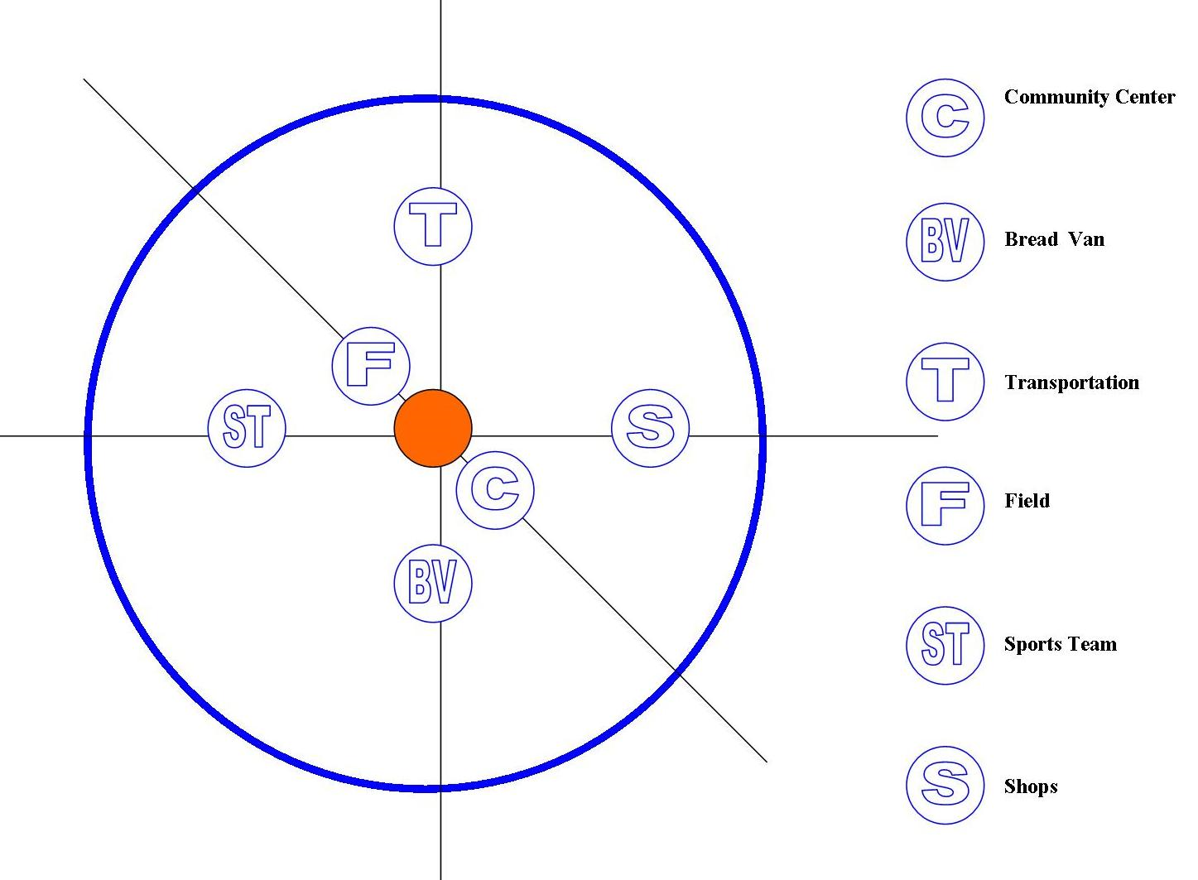

The rural community of Belair is located within the Sarrot community, adjacent to the farming community of Millet. Being as result of a relocation initiative which took place some 14 years ago. The area is still very much without any institutional organizations.

Life within the community is centered predominantly around three major structures:

* Community Center
* Field
* Shops

All major social activities are hosted at the community center and the major sport activities of cricket and football are centered on the field and make shift basketball court.

Due to the absence of a number of usual social structures such as a bakery, Belair is serviced by a bread van which passes through the community on a weekly basis from 6PM. The minibus system is the major source of transportation to and from the community. While this is so, the system usually stops running at about 7PM which hinders the ability of residence to part take in activities outside Belair and late night workers ability to access transportation into the community.

While the seasonal calendar reflects national festivities that are celebrated by Belair, socialization at the community level is centered on the following:

* Attendance at Church, farming and watching of television are the predominant activities of the older persons in Belair;
* Hanging out around the various shops in the community by the young men;
* Playing of Basketball and small goals football and cricket by young men on the field and make-shift basketball court;
* Gathering at the various rum-shops/bars around the community by the older men;
* Playing of Dominoes by all persons;
* Gambling and free style singing by young people around the shops;
* Consumption of alcohol and smoking of marijuana by young men;
* Young women are predominantly engaged in work and taking care of their children;
* The high rate of unemployment and school drop outs among young persons allows for free time to engage in other activities;

### Livelihoods and coping strategies analysis



Belair’s major farming produce is bananas with some level of vegetable and ground provision production, thus farming and farm labour is the predominant livelihood activity engaged in by more than 70% of residence. Employment in the private sector, construction industry and government offices are the other major sources of employment for this community.

The other major and emerging source of employment particularly engaged in by women and the young persons of the community is that of the hotel industry. With the decline in the lucrative nature of the banana industry this sector has been a major employment sector for women and youth.

Difficult times in the community tend to generate support from the following sources:

* Family
* Constituency Representatives (Political party representatives)
* National Social support agencies and NGO’s
* Neighbors
* Friends

It’s noted that during such difficult times a number of day-to-day activities may be affected to ensure some level of survival or coping strategy. The following activities are the major ones affected:

* Shopping for non-basic food items is reduced
* Reduction in leisure time or money spent of such activities such as gambling or weekend “limes”
* Travelling less to the city unless its for school or work related activities
* Children may be kept at home due to the absence of funds for transportation

### Mapping

**Picture: Capacity Resource map**

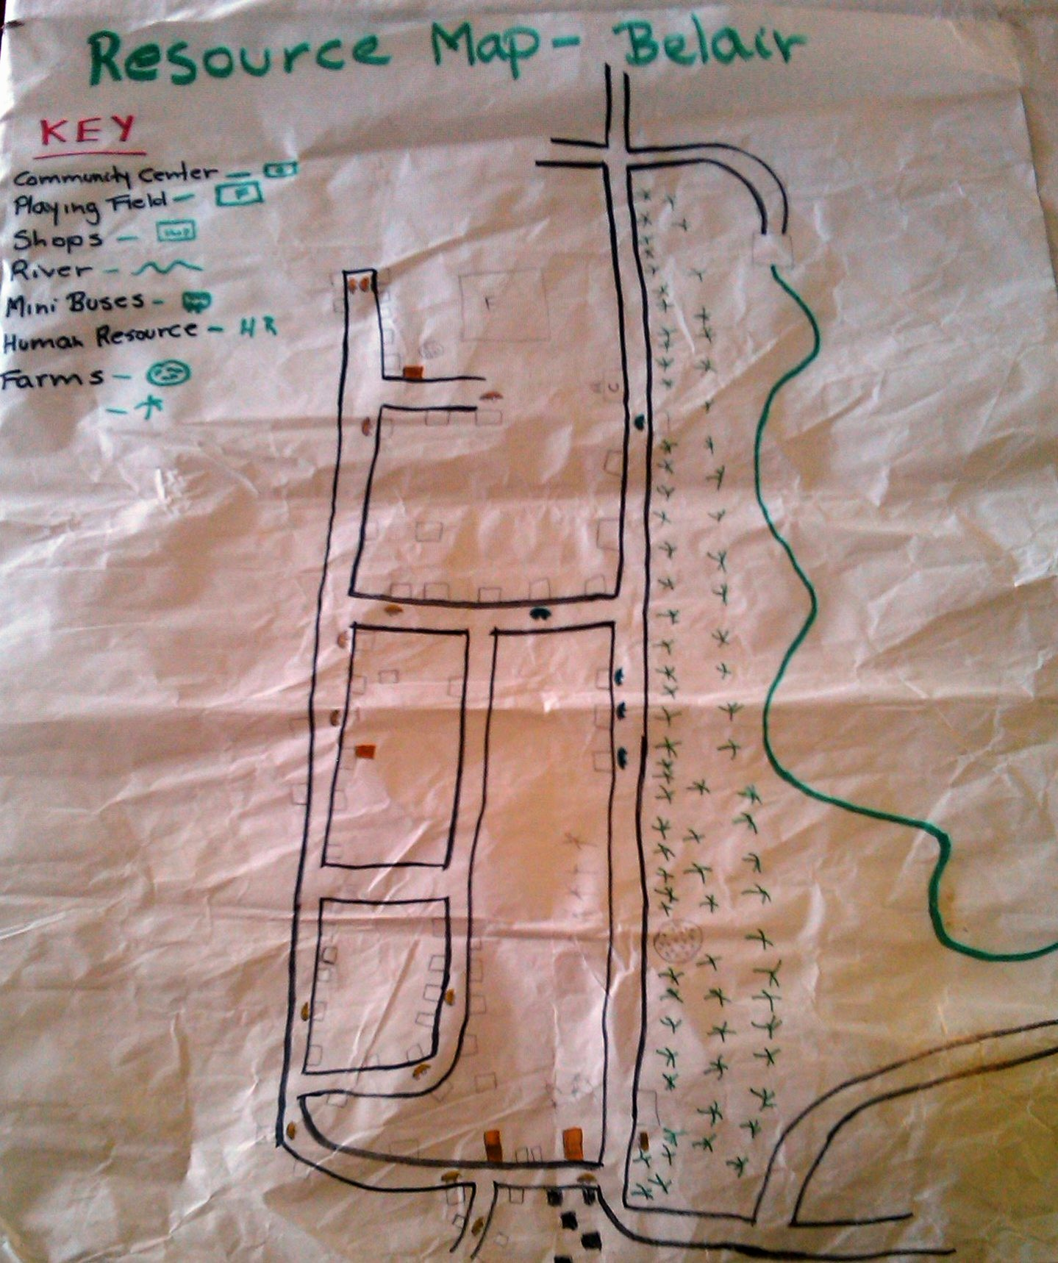

**Picture: Community hazard map**

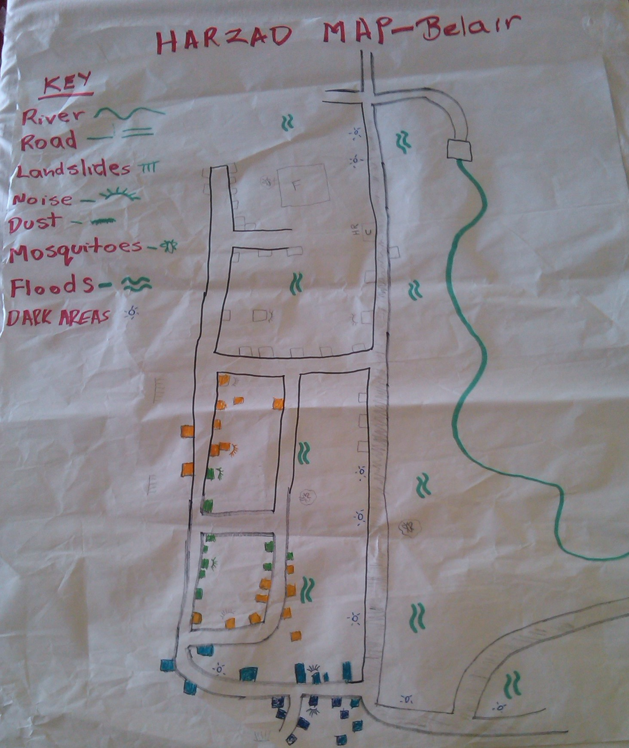

### Transect walk of Belair

Left Side:

|  |  |
| --- | --- |
| **Section: 1 (S. street)** | **Section: 2 (M. street)** |
| * Stagnant water along the road and in drains * Electrical poles are too close to the homes in that area * Block drains which can cause flooding | * Leaning electrical poles next to homes * Overhanging bamboos along the road * Landslide on the left side of the road above homes * Unpaved road * Old vehicle along the road * Old galvanized fence along the road |
| **Section : 3 (Dirty Street)** | **Section: 4 (Vampire Street)** |
| * Clogged drains * Landslide in the ravine * Unpaved road | * Landslide along the road * Pit toilet * Exposed boulders along the road * Fallen Bamboos |
| **Section: 5 (deck-deck Street)** | **Section: 6 (Mad Street)** |
| * Unpaved road * Electrical poles are too close to houses * Derelict vehicle parked close to the road | * Houses are too close to the road * Landslide along the road side * Houses have poorly built roofs and foundations * Road access is minimal, unpaved and difficult to traverse during the evening * Presence of Pit toilets * Poorly constructed galvanized fencing * Clogged drains * Malfunctioning street lights and electrical poles |
|  |  |

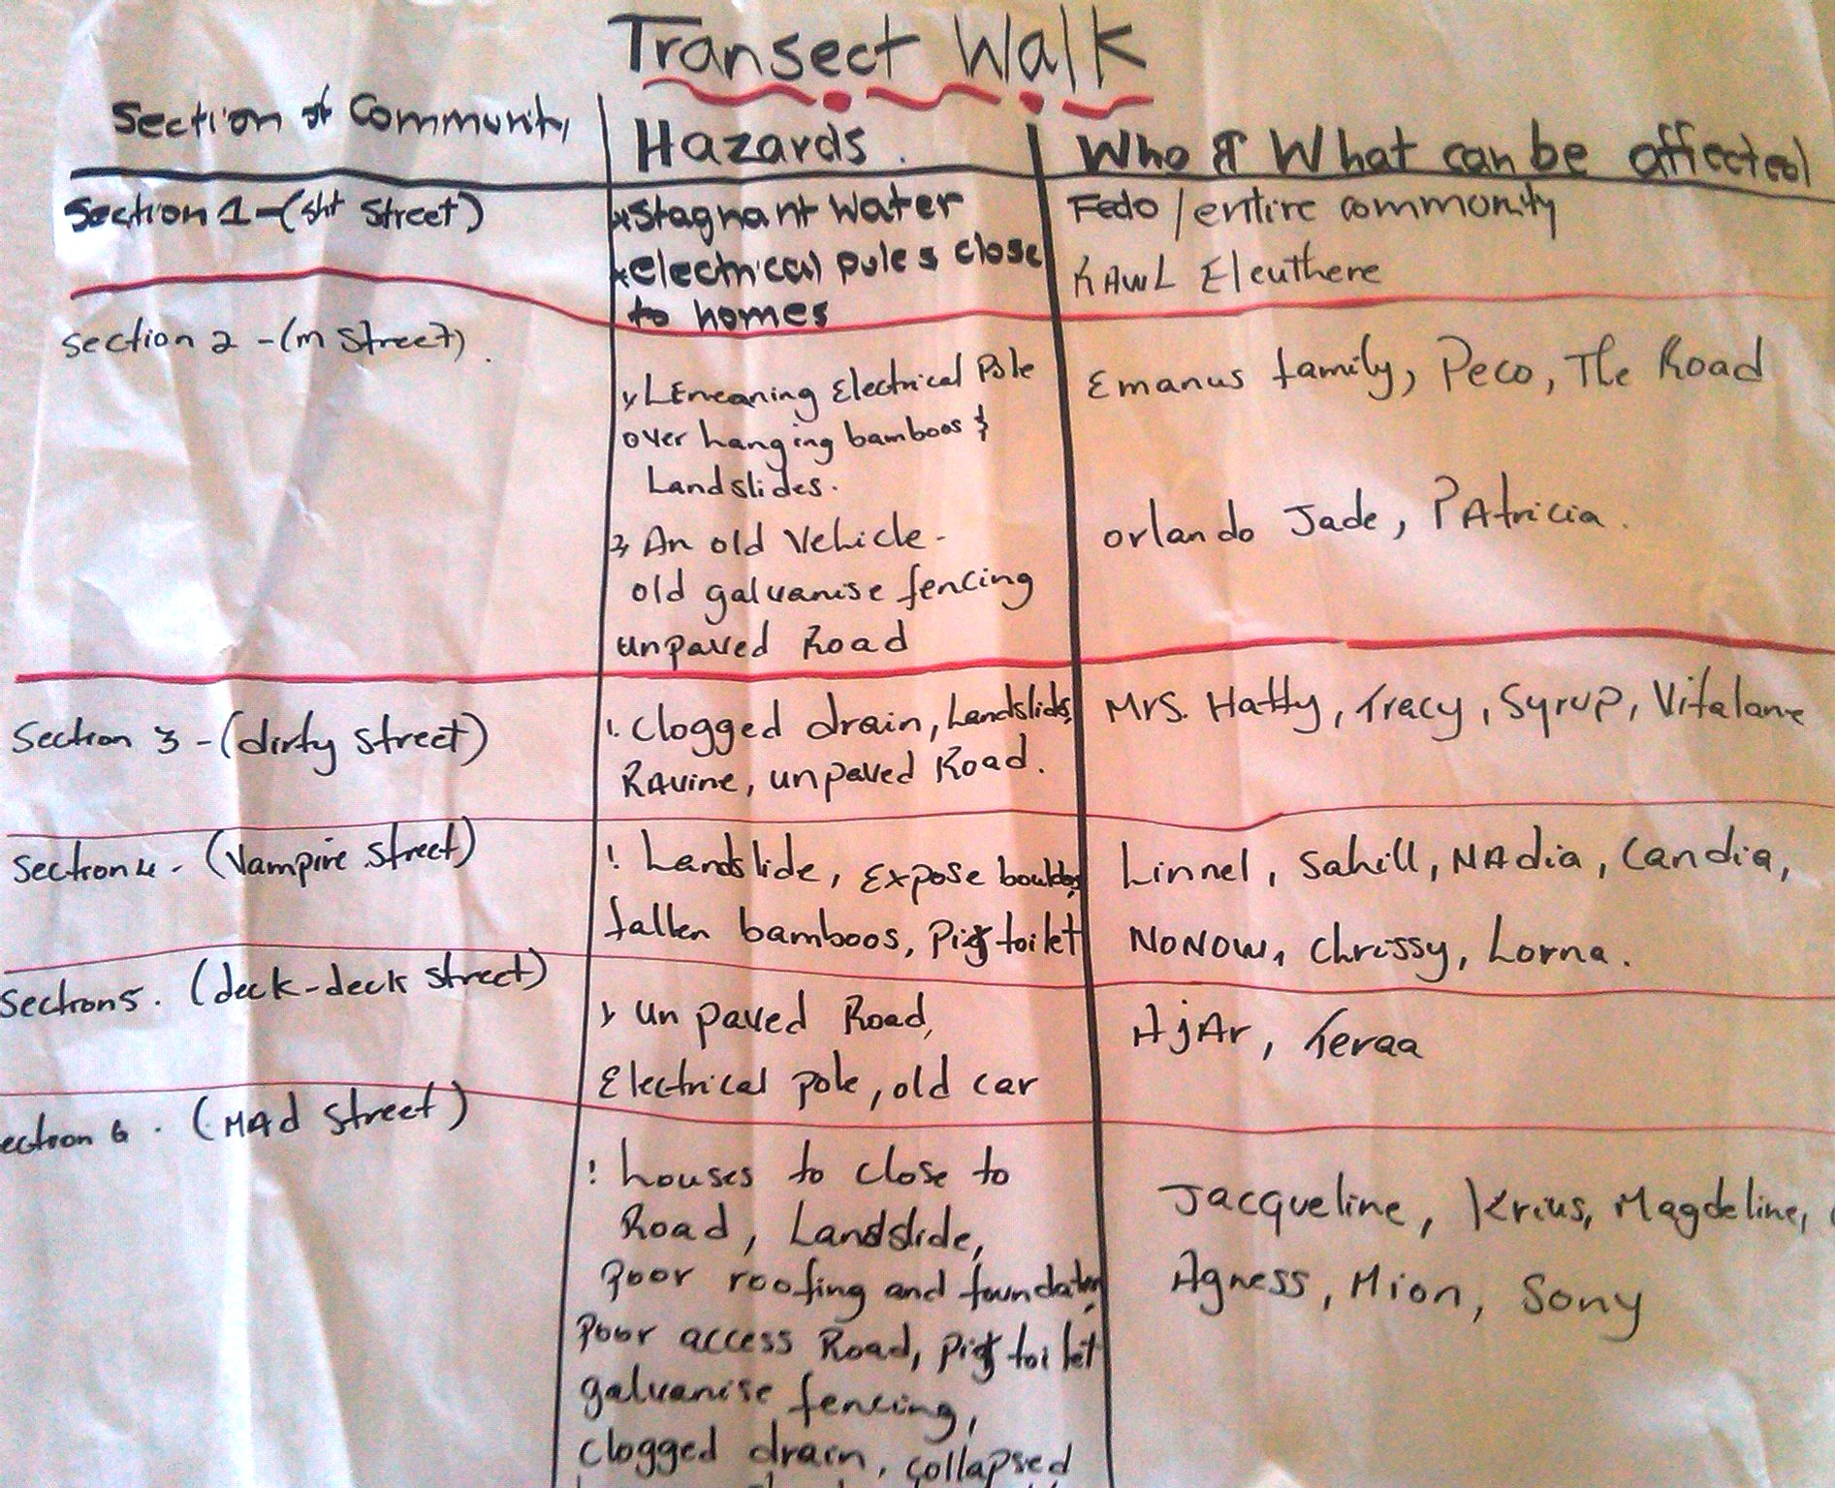

*Analysis of Section 6: (Mad Street)*

The transect walk of Belair revealed the squatting section of the community along “mad street” on the right side of the road seems to be the most vulnerable. The table below highlights the information on this section:

|  |  |
| --- | --- |
| Livelihoods | Persons in this section are predominantly employed as:   * Bus drivers * Construction workers * Vendors * Hotel workers * Sale persons * Shop-keepers |
| Soil type | The area is predominantly of a clay soil and sandy soil in certain sections |
| Hazards | * Houses are too close to the road * Landslide along the road side * Houses have poorly built roofs and foundations * Road access is minimal, unpaved and difficult to traverse during the evening * Presence of Pit toilets * Poorly constructed galvanized fencing * Clogged drains * Malfunctioning street lights and electrical poles |
| Resources/capacities | * Skilled workers are the predominant resource in this section of Belair |
| Population | 55 persons / women: 20 / Men: 17 /children: 16 /Elderly: 1 / Disable: 1 |

### Assessing the capacity of people’s organizations

Currently there exist no community organizations or structures within Belair. While a cricket and football team operates, this happens on a seasonal basis and has no organized structure. The greatest capacity of the community seem to exist with the very presence of persons with a community spirit and the presence of the community center, the field and availability of transportation and heavy equipment.

# Part 2: Risk assessment in Belair

The VCA process made it possible for the St. Lucia Red Cross Society (SLURC) to get toknow Belair while allowing the community members to share their knowledge, their fears and their ideas. At the same time, the project has offered a unique opportunity to go from theory to practice.

The SLURC – in collaboration with partner agencies and local community stakeholders – has used the VCA method to identify and solve problems within their capability. In particular, as the following pages will show, the implementation of the VCA tools improves understanding of:

* the nature and level of risks that vulnerable people face;
* where these risks come from;
* who will be the worst affected;
* what is available at all levels to reduce the risks; and
* what initiatives can be undertaken to strengthen the impact of programs to raise the capacity of people at risk.

### Methodology for a Risk assessment

The following five-step approach was used with the Name of Village community members:

1. The first step meant identifying for each hazard the **Potential Risks to the community**; the areas of vulnerability and capacity that exists within the community.
2. The second step required identifying for each Hazard and **Actions that could be undertaken** to transform vulnerabilities identified into capacities.
3. The third step consisted in differentiating the types of measures, whether they were related to prevention, mitigation or preparation for response.
4. The fourth step involved a CIA Analysis, in which participants considered each and every action to transform vulnerability into a capacity and decide whether such changes were realistic.
5. The fifth and final step involved identifying a Plan of Action that could be implemented by the community. While a number of actions were identified, this final step identified realistic actions. It should be noted that the information gathered and the specific actions identified below while not reflected in the final plan of action are still relevant and needed and could be utilized by other agencies.

The results of these five steps are presented hereafter (points 1 through 5 below).

## Identifying hazards and their potential impact on Belair

|  |  |  |  |
| --- | --- | --- | --- |
| **Hazard** | **Potential Risk** | **Vulnerability** | **Capacity** |
| **River** | * Loss of livelihood * Damage to infrastructure and utilities * Damage to property | * Homes in the lower area of Belair near the river along the main road * Damage to main Belair road * Banana Farms along the river | The community is not blessed with a plethora of resources however the availability of human and physical resources highlighted below will be utilized to undertake the following activities highlighted in the second stage:   * Four wheel drive vehicles * Mini buses * Trucks * Farms and food crops * River * Human resources such as – teachers, nurses, policemen, firemen, forest officers, counselors, farmers and construction workers * Community Center * Field * Access roads * Heavy equipment and operators |
| **Floods** | * Loss of livelihood * Damage to infrastructure and utilities * Damage to property | * Homes in the lower area of Belair near the river along the main road * Damage to main Belair road * Banana Farms along the river |
| **Noise** | * Health of residence | * Persons who live near the source of constant loud music |
| **Dust** | * Health of residence | * Entire community |
| **Mosquitoes** | * Health of residence * Death * Loss of productive days | * Entire community |
| **Roads in the community** | * Loss of lives * Damage to property * Loss of productive days * Loss of school days | * Entire community |
| **Dark areas** | * Loss of lives * Damage to property * Loss of productive days * Loss of school days | * Children, women and elderly persons in the community |
| **Land slides** | * Loss of livelihood * Damage to infrastructure and utilities * Damage to property | * Homes in the upper section of Belair * Farm lands * Roads in upper Belair * Water supply * Utility poles |

## Local capacity of Belair to respond to hazards

|  |  |  |
| --- | --- | --- |
| HAZARD | Vulnerabilities identified | Actions to transform vulnerabilities into capacities |
| **River** | * Homes in the lower area of Belair near the river along the main road * Damage to main Belair road * Banana Farms along the river | * Construction of proper drainage system * Construction of stone baskets along river bank * Regular clearing of drains * Encouraging proper farming practices * Elevation of roads and bridges in community |
| **Floods** | * Homes in the lower area of Belair near the river along the main road * Damage to main Belair road * Banana Farms along the river |
| **Noise** | * Persons who live near the source of constant loud music | * Police intervention to ensure the law is enforce * Discussion with person(s) to ensure they follow the law |
| **Dust** | * Entire community | * Wet road * Paving of road |
| **Mosquitoes** | * Entire community | * Fogging of community by Ministry of Health * Clearing of drains * Clearing of bush and garbage * Proper sewer system |
| **Roads in the community** | * Loss of livelihood * Damage to infrastructure and utilities * Damage to property | * Paving of Roads * Safety Signs on roads |
| **Dark areas** | * Children, women and elderly persons in the community | * Clearing of bush in dark areas throughout community * Installing of electrical poles with lights in dark areas |
| **Landslides** | * Homes in the upper section of Belair * Farm lands * Roads in upper Belair * Water supply * Utility poles | * Construction of retaining walls/stone baskets * Construction of proper drainages and clearing of drains * Planting of trees in vulnerable areas |

## Type of measures to mitigate disasters in Belair

The third step consisted in differentiating the types of measures, along three categories:

* Prevention actions: action which tries to reduce to probability of a disaster in the community;
* Mitigation actions: action that attempts to protect, strengthen, rehabilitate or reconstruct;
* Preparation actions: action that aims to strengthen the capacity of the community of Bamboo to respond in an effective and efficient manner

Identifying prevention, preparation and mitigation activities

|  |  |  |  |
| --- | --- | --- | --- |
| Actions to transform vulnerabilities to capacities | Prevention | Preparation | Mitigation |
| * Construction of proper drainage system |  | **X** |  |
| * Construction of stone baskets along river bank |  |  | **X** |
| * Regular clearing of drains |  |  | **X** |
| * Encouraging proper farming practices |  |  | **X** |
| * Elevation of roads and bridges in community | **X** |  |  |
|  |  |  |  |
| * Police intervention to ensure the law is enforce |  |  | **X** |
| * Discussion with person(s) to ensure they follow the law |  |  | **X** |
|  |  |  |  |
| * Wet road | **X** |  |  |
| * Paving of road |  |  | **X** |
|  |  |  |  |
| * Fogging of community by Ministry of Health |  | **X** |  |
| * Clearing of drains |  |  | **X** |
| * Clearing of bush and garbage |  |  | **X** |
| * Proper sewer system |  |  | **X** |
|  |  |  |  |
| * Clearing of bush in dark areas throughout community |  |  | **X** |
| * Installing of electrical poles with lights in dark areas | **X** |  |  |
|  |  |  |  |
| * Construction of retaining walls/stone baskets |  |  | **X** |
| * Planting of trees in vulnerable areas |  |  | **X** |
| * Construction of proper drainages and clearing of drains |  |  | **X** |

## Ability to act on hazards (CIA/T analysis)

The fourth step involved a CIA Analysis[5], in which participants considered each and every action to transform vulnerability into a capacity and decide whether such changes were realistic. Each problematic situation had to be categorized according to the three possible options:

* the situation can be **changed** with the participation of the people at risk;
* the situation cannot be changed directly, but could be **influenced** by the people at risk so that third parties can offer a solution to the identified need; or
* the situation cannot be changed or influenced and the community needs to **accept** the threat as it is.

|  |  |  |  |  |
| --- | --- | --- | --- | --- |
| **Actions to transform vulnerabilities to capacities** | **Prevention** | **Preparation** | **Mitigation** | **CIA/T** |
| * Construction of proper drainage system |  | **X** |  | **C** |
| * Construction of stone baskets along river bank |  |  | **X** | **I** |
| * Regular clearing of drains |  |  | **X** | **C** |
| * Encouraging proper farming practices |  |  | **X** | **I** |
| * Elevation of roads and bridges in community | **X** |  |  | **I** |
|  |  |  |  |  |
| * Police intervention to ensure the law is enforce |  |  | **X** | **I** |
| * Discussion with person(s) to ensure they follow the law |  |  | **X** | **I** |
|  |  |  |  |  |
| * Wet road | **X** |  |  | **I** |
| * Paving of road |  |  | **X** | **I** |
|  |  |  |  |  |
| * Fogging of community by Ministry of Health |  | **X** |  | **I** |
| * Clearing of drains |  |  | **X** | **C** |
| * Clearing of bush and garbage |  |  | **X** | **C** |
| * Proper sewer system |  |  | **X** | **A/T** |
|  |  |  |  |  |
| * Clearing of bush in dark areas throughout community |  |  | **X** | **C** |
| * Installing of electrical poles with lights in dark areas | **X** |  |  | **I** |
|  |  |  |  |  |
| * Construction of retaining walls/stone baskets |  |  | **X** | **I** |
| * Planting of trees in vulnerable areas |  |  | **X** | **C** |
| * Construction of proper drainages and clearing of drains |  |  | **X** | **I** |

# Conclusion: The next steps

# The group has been engaged in undertaking a number of small projects throughout the community especially focusing on clearing of drains and major land slippage areas. The group has also been undertaking activities to ensure the community is more resilient by helping families to prepare Family Emergency Plans.

# The group has formalize the their CDRT structure by selecting various persons to form the executive of the CDRT, this has paved the way for the action plan and future of the group towards building a safer and healthier Belair.

# Annex 1: List of participants in the Vulnerability and Capacity Assessment

Resource Personnel

|  |  |  |
| --- | --- | --- |
| # | Names | Addresses |
| 452-5582/286-4144 | Ms. Terencia Gaillard | Saint Lucia Red Cross – Director General |
| 452-5582/715-0521 | Mr. Hubert Pierre | Saint Lucia Red Cross- Project Manager |
| 452-5582/719-6824 | Mr. Bennet Charles | Saint Lucia Red Cross- Field Officer |
| 452-0825/ | Mrs. Hilton Oculien | Chief Fire Officer (ret.) |



Focus group meetings – Dates & participants

|  |  |  |  |
| --- | --- | --- | --- |
| Dates | Names | Tel # | Addresses |
| Jan 24th 2011  Feb 7th 2011  Feb 14th 2011  Feb 21th 2011  Feb 28th 2011  March 7th 2011  March 14th 2011  March 21st 2011  March 28th 2011  April 4th 2011  April 11th 2011  April 18th 2011  April 25th 2011  May 2nd 2011  May 16th 2011  May 23rd 2011  June 3rd 2011 | Shirl Alexander | 460-4140 | Belair |
| Bianca Leo | 718-5358 | Belair |
| Nilera Alexander | 721-0533 | Belair |
| Tanny Emmanus | 716-9804 | Belair |
| Daniel Donovan | 715-6001 | Belair |
| Candia Olivier | 520-9029 | Belair |
| Gregor Julian | 518-6766 | Belair |
| Gregory Charlemagne | 716-8711 | Belair |
| Brian Olivier | 520-9029 | Belair |
| Matilda yard |  | Belair |
| Alexander Marcelin |  | Belair |
| Agnes Leo | 717-2337 | Belair |
| Niale Alexander | 721-0533 | Belair |
| Dyon Alexander | 584-1001 | Belair |
| Harold Deligny | 287-9428 | Belair |
| Anthonnis Lascoris | 519-8635 | Belair |
| Joseph Leopold | 287-3604 | Belair |
| Feliciaty leo | 717-4850 | Belair |
| Suenelly Mark | 584-1001 | Belair |
| Vibert Smith | 712-8402 | Belair |
| Curtis Pierre | 488-3079 | Belair |
| John Nestor | 723-2930 | Belair |
|  |  |  |

1. Quoted from *VCA toolbox with reference sheets*, IFRC, Geneva, 2007, page 6.
2. Quote and definitions from *Vulnerability and capacity assessment, An International Federation Guide,* IFRC, Geneva, 1999, page 11-12.
3. Idem, page 12, emphasis added.
4. From *VCA toolbox with reference sheets*, IFRC, Geneva, 2007, page 66.
5. CIA: C = change, I = influence, A = accept, T= transform