**Saint Lucia**

**Red Cross Society**

**Community Risk Reduction**



**Healthier, Safer Communities**

La Resource – Vieux-Fort

**VULNERABILITY AND CAPACITY ASSESSMENT**

***May 2011***

# Acknowledgements

The St. Lucia Red Cross along with the team of dedicated members from the community of La Resource – Vieux Fort would like to express their deepest gratitude to the many persons and institutions who made this document a reality.

To the Red Cross volunteers, NIT members who participated in undertaking the baseline surveys which paved the way forward for this document and the future of the community, thanks for the support. Without a venue the nightly session would have been difficult to conduct and for that we thank the Principal and Security Officer of the Plainview Combined School for the use of the venue to conduct the sensitization meetings along with the VCA Focus Group sessions and CDRT training.

The mobilization of the community by Mr. Barry Charles, Ms. Alma Venor and the dedicated team members whose relentless support even during the Hurricane Tomas relief operation stirred the course towards the finalization of this report. The support given by the government statistic department in making available the secondary data on the community was critical in analysis the outcome of the VCA and we would surely like to thank you for the information and your kind assistance.

To the community members of La Resource Vieux-Fort and the surrounding communities who took time to answer the baseline survey questions and those who cooperated in welcoming the Red Cross members and other community members into their homes and business places during a their difficult times after the passage of Hurricane Tomas to complete the family emergency plans, your efforts and energies are a reflection of the willingness of La Resource to be a safer, healthier and more resilient community.

# Table of contents

Abstract 4

Foreword 5

Introduction 6

Part 1: Vulnerability and Capacity Assessment of La Resource 7

What is VCA? 7

How is the VCA carried out? 8

1. Gathering data from secondary sources 9

2. Direct observation 10-12

3. Focus group discussions 13-21

Part 2: Risk assessment in La Resource 22

Methodology for a Risk assessment 22

1. Identifying hazards and their potential impact on the community 23-24

2. Local capacity to respond to hazards 25-26

3. Type of measures to mitigate disasters 28-27

4. Ability to act on hazards (CIA analysis) 29-30

5. Plan of action 31

Conclusion: The next steps 32

Annex 1: List of participants in the Vulnerability and Capacity Assessment 33

# Abstract

The journey towards the completion of this VCA began in the month of January 2010 with efforts directed at mobilizing this suburban community. The data collection process focused on the major communities which make up La Resource namely; La Resource central, La Tourney, La Retraite, Derriere and Do-Camel.

The impact of the Hurricane Tomas stirred the interests from a group of dedicated persons to approach the Saint Lucia Red Cross to implement the Readiness to Respond Project. The role of the Fond St. Jacques CDRT during Hurricane Tomas served as the main pedestal to have a CDRT established in their community.

Though initial efforts to mobilize the La Resource community proved to be difficult the community spirit from the dedicated few fueled their energies in getting more persons involved in collecting the VCA data and become CDRT members. The final CDRT teams comprises of 17 persons from all the major sections of La Resource.

Entry into the community commenced with a Community Based First Aid session which was conducted with15 participants and focused on basic techniques dealing with Check-Call-Care, stopping of bleeding wounds, treating burns, adult and infant CPR including how to assist a choking victim. The sessions proved worthwhile as it provided participants with much needed skills especially with the sessions which focused on infant and child CPR.

VCA sessions were conducted on Tuesday evenings and Sundays at the Plainview Combined School from 6:00PM. Participants were introduced very early to the mapping exercise along with a historical calendar/pictogram so as to gain appreciation of the development of the community and to rekindle the community spirit. The exploring of the community to draw the spatial map and source information on the history of La Resource proved to be an educational experience for the participants especially during the development the Family Emergency Plans. Though data collection was difficult at times, especially on the history of the community, the dedicated efforts of both young and old brought forth vital pieces of information.

Exploring the social and institutional networks of the community was an activity which brought some reflection on the closeness of the community especially among the various community groups while also revealing the socialization patterns of various groups such as the young, women and older men. This activity along with the transect walk revealed the vulnerable nature of La Resource and initiated discussions on the way forward and possible disaster mitigation projects.

# Foreword

The present VCA study was carried out through a series of community meetings from January – May of 2011 with the residents of La Resource Vieux-Fort

This study is part of the International Federation of Red Cross and Red Crescent Societies (IFRC) regional project “Improving the preparedness of Caribbean communities to respond to disasters affecting their locality”. This program, implemented in 2009-2011, covers the National Societies of Trinidad & Tobago, Surinam, Bahamas, Guyana and Saint Lucia, through the support of the European Commission Office for Humanitarian Aid (ECHO) and the United States Office for Disaster Assistance (OFDA).

# Acronyms

CIA Change / Influence / Accept

CIT Change / Influence / Transform

ECHO European Commission Office for Humanitarian Aid

IFRC International Federation of Red Cross and Red Crescent Societies

OFDA United States Office for Disaster Assistance

VCA Vulnerability and Capacity Assessment

NEMO National Emergency and Management Organisation

SLURC St. Lucia Red Cross

CDRT Community Disaster Response Team

# Introduction

In January 2011, the suburban community of La Resource (La Resource, Dau-Camel, La Retraite, La Tourney and Derriere-Morne) embarked on a journey of self-analysis, examining its strengths and weaknesses, the external and internal threats and the resources it has to cope with these threats. Heads of households, local leaders of religious and sports groups, workers of all trades and other concerned members discussed the history of their community and the problems they encounter. They shared their experiences and their tips for overcoming daily difficulties. As a group, they identified the main problems ahead and discussed the future of their common home.

During the collection of the VCA data the community was recovering along with the rest of Saint Lucia from the impacted by Hurricane Tomas, which caused flooding, landslide and damages to homes in certain parts of the community. This added to the motivation of the community members to participate in sharing information to data collectors for the VCA and during Hurricane Tomas Relief Operations.

The process was organized by volunteers and staff of the St. Lucia Red Cross Society (SLURC), as part of a region-wide attempt to improve community-based disaster preparedness. The community work was based on the methodology known as “Vulnerability and Capacity Assessment”, or VCA. The purpose of this assessment is to identify and understand the most pressing issues and threats in the community (vulnerabilities) while simultaneously identifying the local and external resources available to minimize the risks to the villagers (capacity).

The VCA approach is composed of a series of tools for community-based participatory consultations to ensure a better understanding of how the community functions. Behind this process lies the assumption that a community more aware of its own limitations can organize itself better to overcome them. In the context of the SLURC project, the stated objective was to improve the capacity of the community to cope with the disaster-related risks in its environment.

To this end, the first section summarizes the results from the VCA process, as carried out in La Resource . It presents the history, the local dynamics and the coming challenges, as perceived by the people who live in Name of Village. Although this program explicitly focuses on disasters and hazard mitigation strategies, the results presented in this first section provide guidelines for a broader approach towards sustainable community development.

The second section focuses on the output from the community focus groups in relation to the risks faced by the community: Which are the main risks? Can they be mitigated? By whom? Using the results presented in the proposed Action Plan, the community members – supported by SLURC teams – will identify and implement strategies to mitigate these risks. The information gathered here will also provide the necessary baseline information for monitoring and evaluation the progress of the community.

# Part 1: Vulnerability and Capacity Assessment La Resource - VF

### What is VCA?

Vulnerability and Capacity Assessment (VCA) is a participatory investigative process designed to assess the risks that people face in their locality, their vulnerability to those risks, and the capacities they possess to cope with a hazard and recover from it when it strikes. Through VCA, National Societies can work with vulnerable communities to identify the risks and take steps to reduce them by drawing on their own skills, knowledge and initiative. **In sum, VCA helps people to prepare for hazards, to prevent them from turning into disasters and to mitigate their effects**.[1]

***Vulnerability*** *can be defined as:*

*The characteristics of a person or group in terms of their capacity to anticipate, cope with, resist and recover from the impact of natural or man-made hazards****.***

The definition of vulnerability suggests that it cannot be described without reference to a specific hazard or shock. So, the question that must always be asked is, ''Vulnerability to what?" People living along coastal areas or rivers may be vulnerable to seasonal storms and flooding, while the inhabitants of countries with social, political and economic problems may face difficulties in achieving a satisfactory and sustainable quality of life.

*The reverse of vulnerability is* ***capacity****, which can be described as:*

*The resources of individuals, households, communities, institutions and nations to resist the impact of a hazard.*

The coping strategies of people in response to various hazards will differ from one society to another and will often change over time. People in chronically-prone countries facing multiple hazards, such as drought, locust infestation and civil unrest, find their capacity levels weakening, reducing their ability to mitigate the effects of the next crisis.[2]

### How is the VCA carried out?

The VCA process relies on a few key principles:

**Data collection:** Preliminary data can be collected through the use of questionnaires, developed specifically for each community or for each type of hazard. However, as information is not always immediately available on the ground – because of time constraints, security issues or financial resources – the VCA process also relies on the gathering of secondary data. Precious information about the community can be gathered from research by government bodies, the United Nations and other development- and research-based organizations.

**Community participation:** The goal of the VCA process is to empower the community to allow it to respond on its own to the risks to which it is subjected – or allow it to identify those who can help it to respond. For this reason, community members constitute the core of the process. The main criterion for a successful VCA is the receptiveness of the local community and its willingness to be an active part of the process. Only if all vulnerable groups are included, can they find collective answers to the threats they face.

**Sharing information:** The VCA process helps the community understand its relation to its environment. Through discussions among neighbors and the collection of data, the community members will be better able to understand – and therefore reduce – the threats to which it is subjected. The final VCA document also offers an opportunity to share information beyond the community, by bringing up issues to the relevant authorities, partner organizations or local leaders.

The VCA is mainly used ***to identify in advance, and change where possible, the conditions that create or contribute to the state of vulnerability of at-risk populations***.[3] As such, the main usefulness of VCA comes from an improved understanding of the risks and of measures to mitigate that risk. To gather all information relevant to a better understanding of the community, the following steps have been followed:

1. Review of secondary sources: this first, crucial, step consists in collecting information that already exists, to avoid duplicating efforts already carried out. Most of this phase consists in collecting written material, or identifying all resources relating to a better understanding of the community;
2. Direct observation: A summary presentation of the community, by someone external, often allows to get a first impression of the local dynamics and main issues;
3. Focus group discussions: The heart of the VCA process lies in this phase of community interaction, using tools for the involvement of all stakeholders.

Based on these three steps (presented hereafter in points 1, 2 and 3), disaster-related information has been gathered and is presented in part 2.

## Gathering data from secondary sources

### Location of the community

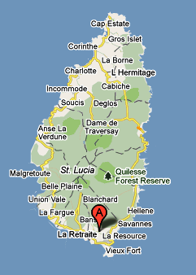The community of La Resource is located in the Southern town of Vieux Fort. La Resource forms the main part of this section with smaller residential areas such as La Retraite, Derriere Morne, Dau-Camel and La Tourney forming the overall community of La Resource.

The Community is about 50-70 Km from the Capital City of Castries or about an hour’s driving via the East or West Coast road.

Coordinates: 13.45.01.56N 60.57.29.97W

### Population of the La Resource – Vieux Fort

2993 Persons / Household Population: 1121

Males: 1522 / Females: 1471

### 

### Community map

### 

## Direct observation

|  |  |
| --- | --- |
| ***Demographics*** | ***Health, Sanitation & Essential Services*** |
| * The community has a population of 2993 persons with a household population of 1121 and an average family size of 2.6; * Gender breakdown: Males- 1552 / Females- 1471; * Males make up 50.8% of the population compared to 49.2% of women; * More than 50% of the population are between the ages of 0-40 reflecting the community has a high percentage young person and middle age persons; * An unemployment population of 25% predominantly among young persons; (males: 22%, females: 30%) * 62% of households are headed by men; * Dwelling houses are predominantly made from concrete blocks 48% of the material used; * The community is made up of a combination of educated and low literacy level persons. 37% of the population only as a Primary school education with 20% having attended secondary school; * 11% of the community members has no form of formal education; | * The community is serviced by the makeshift St. Jude’s Hospital housed at the George Odlum Stadium after a fire destroyed most of the structure in June of 2009. This facility is just about 5mins drive from the community. Other medical services can be sourced at the Vieux-Fort Health Center in the center of the Vieux Fort town about 15minutes driving time. * The community has access to a Pre-School, the Plainview Combined School and the largest secondary school on island which also houses a Post Secondary unit, the Vieux-Comprehensive Campus B; * There is the presence of 2 church buildings, the Seventh Day Adventist Church and Church of God; * Police presence can be had from the Vieux-Fort Police Station about 15 minutes driving distance away. * Medical and Fire Emergency Services is accessed from the Vieux-Fort Fire Station also 15 minutes driving distance away. * The community has a good network of paved roads especially in the La Tourney and Dierre Morne areas; * The only International Airport on the island is about 15 minutes driving distance away from the community; * A good garbage collection system exists throughout the community; * Pipe borne water exists within the community and most persons access water from their homes, however the river is also utilized during water shortages and for agricultural purposes; * Almost 50% of houses have a septic tank system of toilet; * 25% of homes still use the Pit Latrine (VIP) which s a drastic reduction from almost 40% around 2001; * Electricity is available throughout the community and most roads are well lit; * Landlines (telephone) are widely available in the community however mobile phones are the primary form of communication with 85% of persons owning a cell phone; * The International American Medical University, a medical University is located in the immediate vicinity of the community; |
| ***Daily Activities*** | ***Visible Vulnerabilities and Capacities*** |
| * Adults are predominantly engaged in economic activities throughout the better part of the day * Women are generally involved in employment, caring of children and church related activities; * Sports and other recreational activities are centered on the Playing field behind the Primary School or the Court on the grounds of Campus B * Recreational activities of adults tend to stem around the playing of dominoes, attending “Country and Western” dances and watching television; * Adult males tend to socialize around the community bars, playing dominoes and engaging in other local games. * A large percentage of men are either employed in the farming or construction industry; * Catholicism, Seventh Day Adventist and Pentecostal are the dominant denominations in La Resource * Public Transportation plays a vital role in the daily lives of residence and is the major form of transportation used by the community; * A large percentage of youth tend to participate more in “liming” around the community especially on weekends; | ***Vulnerabilitie****s*   * The presence of the Gas station and LPG sales point at the corner of the La Resource and Augier Road exposes the community to the risk of fires and explosions; * Two other LPG sales point in close proximity to the Pre School and Primary School * The river which runs along the Dierre Morne Section of the community also brunches out into a ravine which runs through La Resource and La Tourney; * The ravine also runs to the back of the Plainview Combined School and a number of homes in the vicinity; * Erosion along the banks of the river; * Large areas of bush in the La Resource and Dierre Morne area which tends to habour rodents; * The close proximity of utility poles predominantly electricity to homes and community shops and the Primary and Secondary Schools; * High percentage of wooden houses couple with poor roof structures in the La Tourney, Dierre Morne and La Resource area; * Sale of illegal drugs especially between Do- Camel and the Dierre Morne road; * Abandoned old buildings; * Stagnant water in the upper portion of La resource along the ravine; * Vehicular traffic and reckless driving along the La Resource road; * The presence of Windward and Leeward Brewery in close proximity to La resource exposes the community to a risk of explosion or fires; * Presence of pig pens along the river;   ***Capacities***   * Availability of small community shops; * Farmland and crops; * Animal farms; * Windward and Leeward Brewery * Gas Station * St. Jude’s Hospital * Community Laundry * Cemetery * LPG sales points * Playing Field * Schools- Plainview Combined, Pre-School, Vieux-Fort Comprehensive Secondary, International American University; * River and ravine * Human resources (teachers, doctors, medical students, technicians, police/fire officers, mechanics, heavy equipment operators, farmers, construction workers, etc.) * Heavy equipment, minibuses * Four Wheel Drive Vans and trucks * Health Center, * 1 Seventh Day Adventist Church * 1 Pentecostal Church * 1 Catholic Church * Roads and access routes along with bridges * Trees * Chain saws and operators * Multi-purpose Court at the Primary and Secondary School |

## Focus group discussions

***A focus group discussion is a qualitative information-gathering tool whereby a group of selected individuals, guided by a facilitator, are invited to give their thoughts and views on a specific issue***.[4] To facilitate the process of interaction with key community stakeholders, the International Federation has developed a series of tools for participatory appraisals. These include, but are not limited to:

1. Historical profile;
2. Historical visualization;
3. Seasonal calendar;
4. Institutional and social network analysis;
5. Livelihoods and coping strategies analysis;
6. Mapping;
7. Transect walk;
8. Household/neighborhood vulnerability assessment;
9. Assessing the capacity of people’s organizations;
10. Venn diagram.

Not all tools are used every time, nor are these tools the only ones used to encourage community mobilization. More than the tools, the success of the VCA is measured by the mobilization it induces within the targeted community.

1. Historical profile;
2. Seasonal calendar;
3. Institutional and social network analysis;
4. Livelihoods and coping strategies analysis;
5. Mapping;
6. Transect walk;
7. Household/neighborhood vulnerability assessment;

### Historical Calendar: La Resource - VF

|  |  |
| --- | --- |
| **Year** | **Event** |
| 1953 | Plain View Combined School |
| 1969 | Roman Catholic Church in Dierre Morne |
| 1972-73 | Vieux-Fort Comprehensive Secondary Campus B |
| 1974 | Windward and Leeward Brewery Ltd commences operation |
| 1980 | Hurricane Allen impacts the island and the community |
| 1994 | La Tourney Cemetery opens |
| Tropical Storm Debbie impacts the island and the community |
| 1996 | Rambally Funeral Parlor opens |
| 1997 | Electricity at La Tourney |
| 1998 | La Resource Community Mart opens |
| Mr. Mikes Garage opens |
| 2005 | La Resource Private Cemetery commences operations |
| 2006 | Feeder roads in La-Resource constructed |
| S.D.A. Church in La-Resource constructed |
| 2007 | Pentecostal Church in Dierre-Morne constructed |
| 2009 | St. Jude’s Hospital destroyed by fire |
|  | St. Jude’s Hospital commences operation at George Odlum Stadium |
| 2010 | Hurricane Tomas impacts the island and the community |
| 2011 | CDRT established in La-Resource |

The community of La-Resource has gradually developed from a sort of rural community in the town of Vieux-Fort to a suburban community which has flourished throughout the years. The presence of major infrastructural projects such as the largest Secondary School on the island, the Windward and Leeward Brewery, the International Airport, the St. Jude’s Hospital, George Odlum stadium, positions the community as a model for development.

Its growth and development continued especially with housing projects in the La Tourney area and movement of persons away from major towns into more comfortable settings such as that of La Resource.

### Seasonal calendar

|  |  |  |  |  |  |  |  |  |  |  |  |  |
| --- | --- | --- | --- | --- | --- | --- | --- | --- | --- | --- | --- | --- |
| **Activity** | **J** | **F** | **M** | **A** | **M** | **J** | **J** | **A** | **S** | **O** | **N** | **D** |
| New Year Festivities | **X** |  |  |  |  |  |  |  |  |  |  |  |
| Independence Anniversary |  | **X** |  |  |  |  |  |  |  |  |  |  |
| Lent and Easter activities |  |  | **X** | **X** |  |  |  |  |  |  |  |  |
| Mother’s Day Activities |  |  |  |  |  |  |  |  |  |  |  |  |
| Mother’s & Father’s Group Anniversary |  |  |  |  | **X** |  |  |  |  |  |  |  |
| School Sports |  |  |  |  | **X** |  |  |  |  |  |  |  |
| Father’s Day |  |  |  |  |  | **X** |  |  |  |  |  |  |
| Carnival |  |  |  |  |  |  | **X** |  |  |  |  |  |
| Jounen Kweyol |  |  |  |  |  |  |  |  |  | **X** |  |  |
| Christmas Celebrations |  |  |  |  |  |  |  |  |  |  |  | **X** |
|  |  |  |  |  |  |  |  |  |  |  |  |  |
| **Hazard** |  |  |  |  |  |  |  |  |  |  |  |  |
| **Floods** | **x** |  |  |  |  | **x** | **x** | **x** | **x** | **X** | **X** | **x** |
| **Hurricane** | **x** |  |  |  |  | **x** | **x** | **x** | **x** | **X** | **X** | **x** |
| **Fires** | **x** | **x** | **x** | **x** | **x** | **x** | **x** | **x** | **x** | **x** | **x** | **x** |
| **Road accidents** | **x** | **x** | **x** | **x** | **x** | **x** | **x** | **x** | **x** | **x** | **x** | **x** |
| **Earthquakes** | **x** | **x** | **x** | **x** | **x** | **x** | **x** | **x** | **x** | **x** | **x** | **x** |
|  |  |  |  |  |  |  |  |  |  |  |  |  |

### Institutional and social network analysis

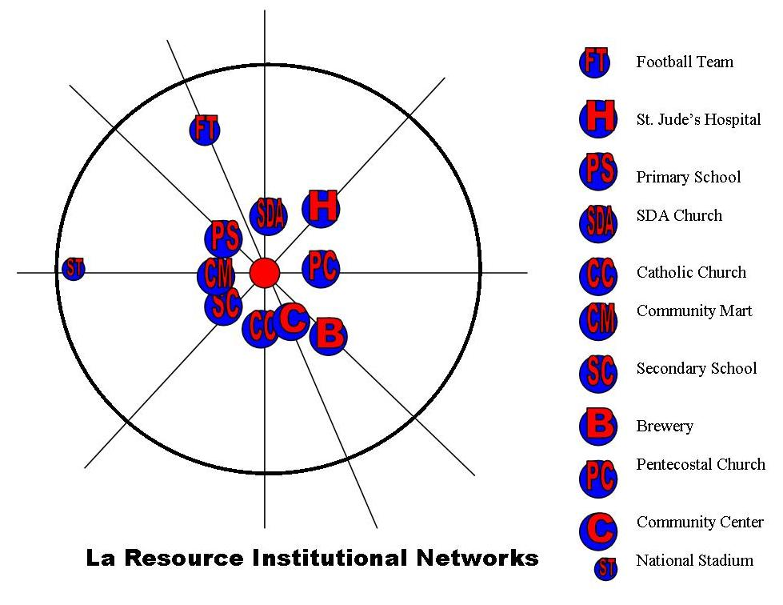

La Resource has a number of social institutions that are not common to other communities on the island and thus positions it as a very unique suburban area. The major ones which tend to be at the center of community life are as follows:

* St. Jude’s Hospsital
* Day Care
* The three churches
* Secondary and Primary School
* Community Center

Private sector companies like the Brewery, the Medical University would provide some level of support if approached but are not seen as critical components of the community as those mentioned above.

La Resource has a number of social institutions that are not common to other communities on the island and thus positions it as a very unique suburban area. The major ones which tend to be at the center of community life are as follows:

* St. Jude’s Hopsital
* Day Care
* The three churches
* Secondary and Primary School
* Community Center

Private sector companies like the Brewery, the Medical University would provide some level of support if approached but are not seen as critical components of the community as those mentioned above.

Other than the football team, church related organizations and the Mother’s and Father’s group, the community does not really have any other structures with a focus on community development. Thus it is hope with the establishment of a CDRT and new focus on community developed will come forth.

### Livelihoods and coping strategies analysis

This suburban community has a most varied formed of livelihoods particular due to a variation of educational level and socio-economic status. The predominant fields are livelihoods which employ more 5% or more of the population is the areas of farming (banana and livestock). The hotel sector as is the trend in most communities employs just about 4% of the population. The construction industry and business management also make a considerable contribution to employment.

The livelihood graph reflects that this community is not dependant on one specific area of income generation and is a reflection of the diversity of skills and resources in the community.

Security guards along with heavy equipment operators and mini-bus drivers are the other major contributors, employing 2-3% of persons.

During difficult times community members tend to reduce on the following to deal with the reduction in income or economic activity:

* Traveling to Castries
* Less recreational activities
* Reduction in the amount of groceries
* Sending children to school

The following structures are turned to for support:

* Neighbors and Family members
* Church Organisations
* Friends

### Mapping

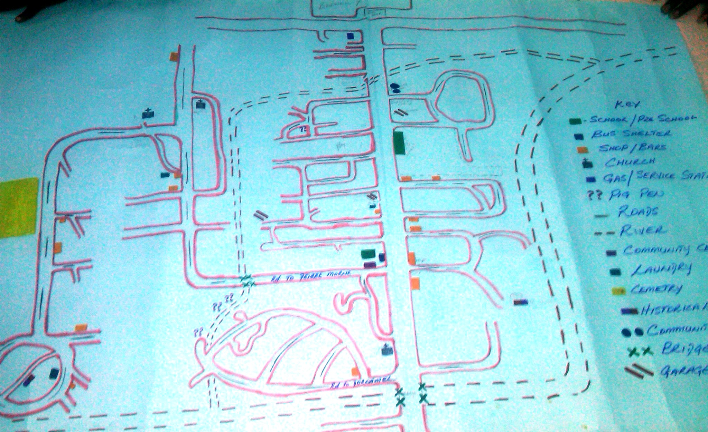**Picture: Capacity Resource Map**

**Picture: Hazard map**

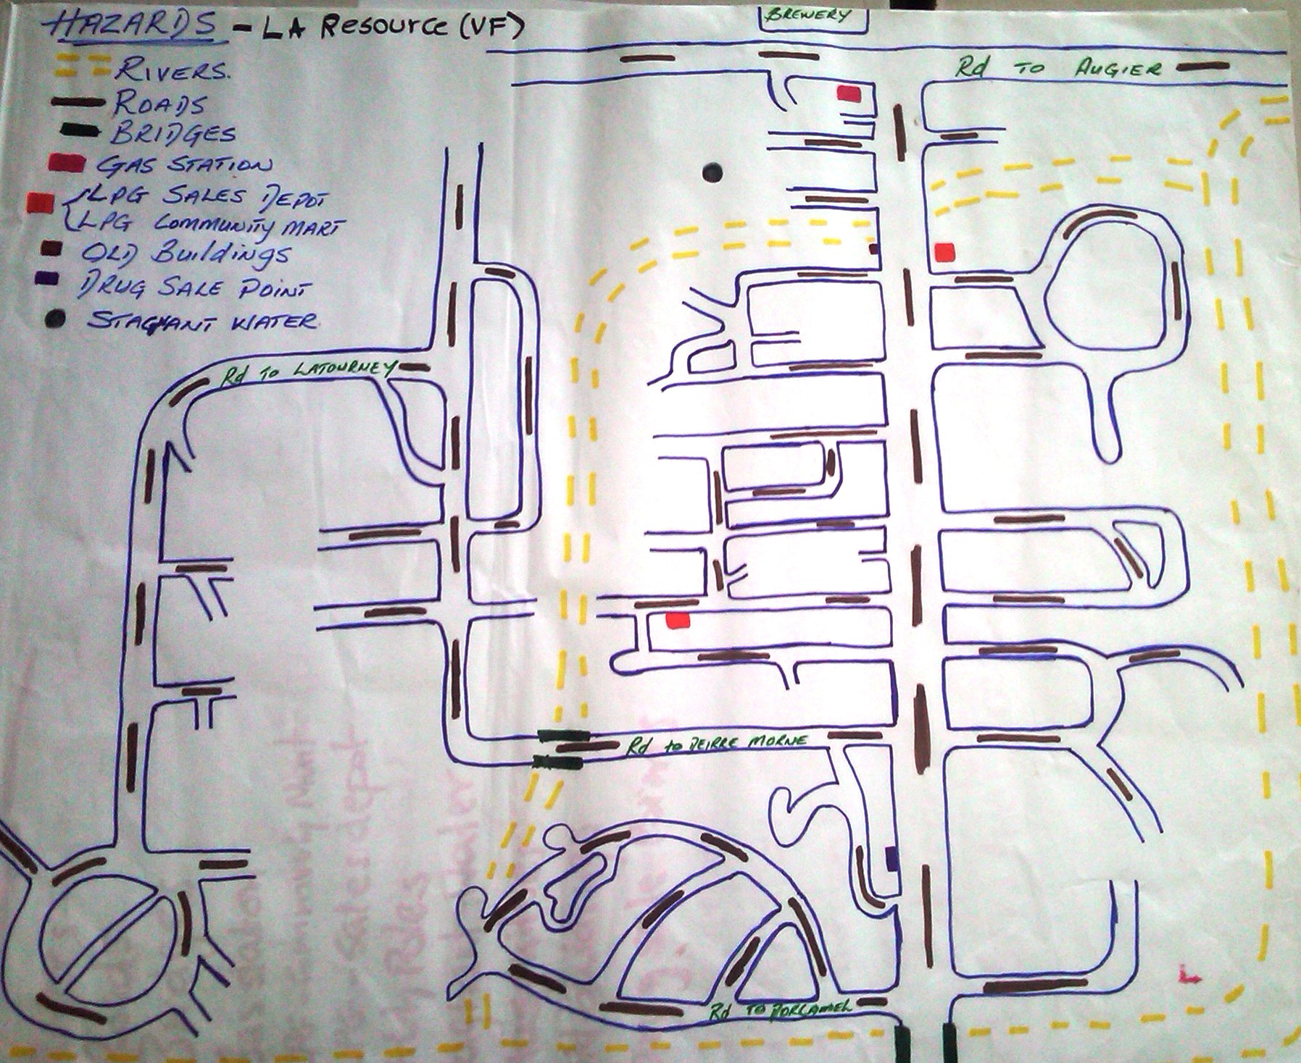

1. **Transect walk**

|  |  |
| --- | --- |
| La Resource to Dierre-Morne Gap | |
| Characteristics | This is the more central section of the community, which runs along the main highway. This section is predominantly flat and a main section of the ravine run through this area.  The Primary, Secondary and Pre-School are within this vicinity. |
| Livelihoods | Farmers, Minibus drivers, shop-keepers, butchers, civil servants, construction workers, hotel workers; |
| Hazards | Flooding from the river, over hanging trees, vehicular accidents, utility poles close to homes and businesses, risk of fires and explosions from LPG sales Points, Gas Station and Brewery, galvanized fencing and poorly built roofs; |
| Resources | Farmlands and crops, river, transportation, skilled workers, shops, heavy equipment, Brewery, LPG Sales Points, Schools, Church; |
| Soil Type | Predominantly clay loam soils with some parts having soil of a sandy loam nature due to the river; |
| Household Population | 455 houses |

|  |  |
| --- | --- |
| Dierre Morne – Do-Camel Gap | |
| Characteristics | This is a more of a residential section of the community and in close proximity to the main river and a section of the main road. The community is a bit more elevated than other sections of La Resource expect for La Tourney which is also elevated. |
| Livelihoods | Farmers, Minibus drivers, shop-keepers, butchers, civil servants, construction workers, hotel workers, Police Officers; |
| Hazards | Landslides, Flooding from the river, over hanging trees, vehicular accidents, utility poles close to homes and businesses, galvanized fencing and poorly built roofs, pollution of water ways from pig pens; |
| Resources | Farmlands and crops, river, paved roads and bridges, transportation, skilled workers, shops, heavy equipment, Churches; |
| Soil Type | Predominantly clay loam soils |
| Household Population | 194 houses |

|  |  |
| --- | --- |
| La Tourney | |
| Characteristics | This is an elevated section of the community and some level of planning as it came about due to a housing development project. This area has two major sections which comprises of previous residents and those from the housing project. Thus two types of homes are common in the community, plywood and concrete structures.  This section also houses a private cemetery and burial services business. |
| Livelihoods | Minibus drivers, shop-keepers, civil servants, construction workers, hotel workers; |
| Hazards | Landslides, over hanging trees, vehicular accidents, utility poles close to homes and small shop, galvanized fencing and poorly built roofs |
| Resources | Community Center, Schools, Day Care, Farmlands and crops, river, transportation, skilled workers, shops, heavy equipment, Forest trail, Post Office; |
| Soil Type | Predominantly clay loam soil with some rocky sections on the elevated plains; |
| Household Population | 358 houses |

### Household/neighborhood vulnerability assessment

Population: 2993 Household type: Concrete-48% / Concrete – 39% /Mixed – 13%

Males: 1552 / Females: 1471 Poverty Index: Lower Class – Upper Middle

Unemployment: 25% Household Population: 1121

Family Size Average: 2.6/persons

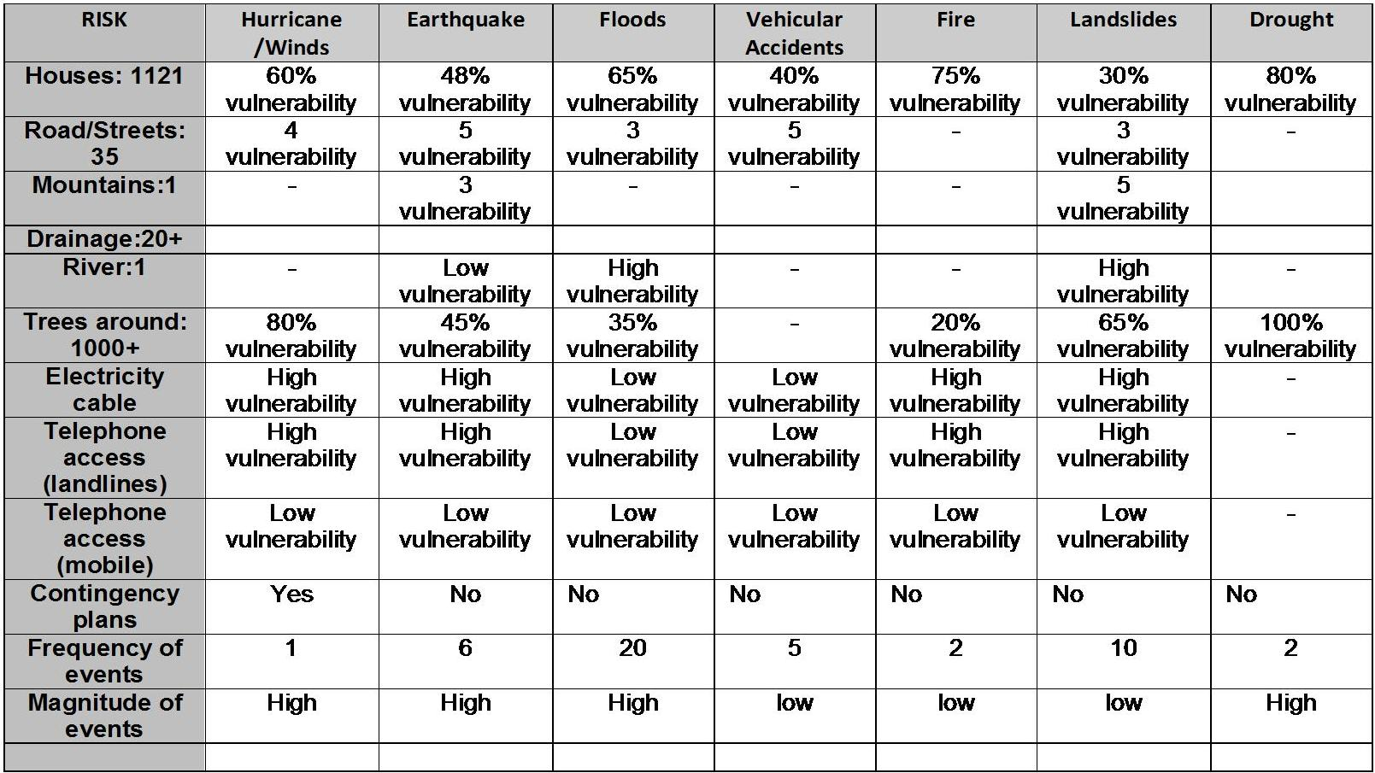

More than 48% of the homes in the La Resource area, especially in La Tourney are made of concrete and thus are vulnerable to earthquake including houses on the elevated section of the community. The assessment revealed that out of the 1121 homes, 60% of them are vulnerable to hurricane wind damage.

The other major risk which homes and the rest of the community are exposed to, is their vulnerability to Landslides and Flooding. In the low areas 65% of homes and small shops are vulnerable due to the fact that the river runs throughout the entire community and the sections of the community are connected via bridges which are very vulnerable to flood waters.

Though La Resource is very much a low area some parts of the La Tourney, La Retraite and Dierre Morne are prone to some level of Landslides. Just 30% of the homes exposed have some level of exposure to this hazard.

# Part 2: Risk assessment in La Resource

The VCA process made it possible for the St. Lucia Red Cross Society (SLURC) to get toknow La Resource, while allowing the community members to share their knowledge, their fears and their ideas. At the same time, the project has offered a unique opportunity to go from theory to practice.

The SLURC – in collaboration with partner agencies and local community stakeholders – has used the VCA method to identify and solve problems within their capability. In particular, as the following pages will show, the implementation of the VCA tools improves understanding of:

* the nature and level of risks that vulnerable people face;
* where these risks come from;
* who will be the worst affected;
* what is available at all levels to reduce the risks; and
* what initiatives can be undertaken to strengthen the impact of programs to raise the capacity of people at risk.

### Methodology for a Risk assessment

The following five-step approach was used with the Name of Village community members:

1. The first step meant identifying for each hazard the **Potential Risks to the community**; the areas of vulnerability and capacity that exists within the community.
2. The second step required identifying for each Hazard **Actions that could be undertaken** to transform vulnerabilities identified into capacities.
3. The third step consisted in differentiating the types of measures, whether they related to prevention, mitigation or preparation for response.
4. The fourth step involves a CIA Analysis, in which participants considered each and every action to transform vulnerability into a capacity and decide whether such changes were realistic.
5. The fifth and final step involved identifying a Plan of Action that could be implemented by the community. While a number of actions were identified, this final step identified realistic actions. It should be noted that the information gathered and the specific actions identified below while not reflected in the final plan of action are still relevant and needed and could be utilized by other agencies.

The results of these five steps are presented hereafter (points 1 through 5 below).

## Identifying hazards and their potential impact on the community

|  |  |  |  |
| --- | --- | --- | --- |
| Hazard | Potential Risk | Vulnerability | Capacity |
| **River/Flooding** | * Loss of life and Property * Loss of livelihood * Damage to property * Damage to access routes * Damage to road/bridges | * Lower sections of the communities with farms and homes * Small shops close to the river and bridges * Playing Field * Plain View and Campus B schools * Bridges throughout the entire community | This community has a wealth of resources both physical and human and these same resources are usually called upon to assist in the development or needs of the community.  Below is a list of some of the resources available to the community in ensuring there development towards a safer and more resilient La Resource  ***Human Resources:***   * *Heavy equipment operators* * *Minibus drivers* * *Technicians* * *Fishermen* * *Farmers* * *Police Officers* * *Nurses* * *Firemen* * *Educators* * *Plumbers/Electricians* * *Construction workers* * *Member of Parliament* * *Mechanics* * *Disaster Preparedness workers* * *Tailors/Dress makers* * *Mechanics*   ***Physical Resources***   * *Heavy equipment* * *Four wheel drive vehicles* * *Trucks* * *Minibuses* * *Crops and Farm lands* * *Lumber* * Health Center * Community Centers * School and Church Buildings * Construction equipment * St. Jude’s Hospital * George Odlum Stadium * Windward and Leeward Brewery * Medical University |
|  |  |  |
| **Landslides/Steep slopes** | * Loss of farm lands and crops * Loss of land * Loss of property * Damage to utility poles * Damage to homes and businesses * Loss of life * Loss of livelihood * Damage to access routes/roads and bridges * Damage to water mains * Difficulties in sourcing lands for relocation | * Homes in sections of La Tourney, Dierre Morne, La retraite above or just below sloping areas * Road sections in Dierre Morne |
|  |  |  |
| **La Resource road** | * Vehicular accidents * Loss of life and Property * Loss of livelihood * Damage to property | * Workers * Passengers * Staff and Students of the various schools * Pedestrians * Motorist * Homes and small shops along the road |
|  |  |  |
| **Drought** | * Loss homes and businesses * Loss of productive days, school/work * Damage to homes and property * Loss of livelihood * Loss of Wild Life * Bush fires * Loss of life | * Farm lands in the community * La Resource river * Crops * Homes close to trees especially in the interior of the community * Homes in La Resource * Schools |
|  |  |  |
| **Overhanging Trees** | * Damage to utility poles * Damage to homes and property | * Electricity and telephone poles along the road and within the community * Some houses and shops along the road * Motorist and Pedestrians |
|  |  |  |
| **Fire** | * Loss of lives * Loss of productive days * Damage to property * Loss to property | * Homes and small shops in the community; * Residents |
|  |  |  |
| **Earthquake** | * Damage Water and utilities mains * Loss of lives * Loss of Property * Fires and explosions * Damage to property * Loss of land holdings * Damage to access routes and bridges * Damage to Dam | * Bridges throughout the community * Campus B * Some sections of the Primary School * Community Center * Homes particularly concrete ones * Churches in the community * Funeral home |
|  |  |  |
| **Hurricanes/Winds** | * Loss of life and Property * Loss of livelihood * Damage to property * Damage to community infrastructures | * Residents of La Resource * Community Center * Primary and Secondary School * Day Care * Community Mart * Wooden houses throughout the community with poor roofs * Small wooden shops in the community |

## Local capacity to respond to hazards

|  |  |  |
| --- | --- | --- |
| **Hazard** | **Vulnerability** | **Actions to transform vulnerabilities into capacities** |
| **River/Flooding** | * Lower sections of the communities with farms and homes * Small shops close to the river and bridges * Playing Field * Plain View and Campus B schools * Bridges throughout the entire community | * De-silting of river; * Planting of trees to stabilize river bank * Helping families to plan for emergencies * Clearing and construction of drains around homes |
|  |  |  |
| **Landslides/Steep slopes** | * Homes in sections of La Tourney, Dierre Morne, La retraite above or just below sloping areas * Road sections in Dierre Morne | * Encourage farmers to practice better farming practices; * Planting of trees to stabilize slops; * Relocation of threaten homes; * Construction of drains to redirect water flow; |
|  |  |  |
| **La Resource road** | * Workers * Passengers * Staff and Students of the various schools * Pedestrians * Motorist * Homes and small shops along the road | * Road safety education programme for the community and other road users * Installation of Road Safety Sign |
|  |  |  |
| **Drought** | * Farm lands in the community * La Resource river * Crops * Homes close to trees especially in the interior of the community * Homes in La Resource * Schools | * Promote water conservation techniques; * Encourage farmers to practice water conservation techniques; * Promote rain water harvesting and storage among residents and farmers; |
|  |  |  |
| **Overhanging Trees** | * Electricity and telephone poles along the La Resource road and within the community * Some houses and shops along the road * Motorist and Pedestrians | * Trimming of trees around homes and businesses * Alerting relevant utility companies about trimming of trees |
|  |  |  |
| **Fire** | * Homes and small shops in the community; * Residents | * Fire prevention education * Establish bucket brigade for community * Encourage small business and shops to install fire extinguishers * Encourage homes to install smoke detectors * Conduct fire drills in community and other institutions * Fire Safety Programme for Plainview Combined |
|  |  |  |
| **Earthquake** | * Bridges throughout the community * Campus B * Some sections of the Primary School * Community Center * Homes particularly concrete ones * Churches in the community * Funeral home | * Encourage the development of Family emergency plans; * Promote earthquake impact reduction; techniques in the community; * Community Education sessions for residents * Develop earthquake contingency plan for La Resource and other sections of community; * Practice drills at the community level; |
|  |  |  |
| **Hurricanes/Winds** | * Residents of La Resource * Community Center * Primary and Secondary School * Day Care * Community Mart * Wooden houses throughout the community with poor roofs * Small wooden shops in the community | * Develop Family Emergency Plans with community members * Encourage persons to retrofit their roofs * Conduct roof inspection and provide assistance to elderly persons in retrofitting roofs * Conduct drills in the community to promote preparedness |

## Type of measures to mitigate disasters

The third step consisted in differentiating the types of measures, along three categories:

* Prevention actions: action which tries to reduce to probability of a disaster in the community;
* Mitigation actions: action that attempts to protect, strengthen, rehabilitate or reconstruct;
* Preparation actions: action that aims to strengthen the capacity of the community of Bamboo to respond in an effective and efficient manner

Identifying prevention, preparation and mitigation activities

|  |  |  |  |
| --- | --- | --- | --- |
| **Actions to transform vulnerabilities into capacities** | | | |
| **Hazard** | **Prevention** | **Preparedness** | **Mitigation** |
| **River/Flooding** |  | * Helping families to plan for emergencies | * De-silting of river; * Construction of retaining walls along river bank * Planting of trees to stabilize river bank * Clearing and construction of drains around homes |
|  |  |  |  |
| **Landslides**  **/Steep slopes** | * Relocation of threaten homes; |  | * Construction of drains to redirect water flow; * Encourage farmers to practice better farming practices; * Planting of trees to stabilize slopes; |
|  |  |  |  |
| **La Resource road** |  | * Road safety education programme for the community and other road users | * Installation of Road Safety Signs |
|  |  |  |  |
| **Drought** |  | * Promote rain water harvesting and storage among residents and farmers; * Promote water conservation techniques in the homes; * Encourage farmers to practice water conservation techniques; |  |
|  |  |  |  |
| **Overhanging Trees** |  |  | * Trimming of trees around homes and businesses; * Alerting relevant utility companies about trimming of trees |
|  |  |  |  |
| **Fire** |  | * Conduct fire drills in community and other institutions; * Establish bucket brigade for community; | * Encourage small business and shops to install fire extinguishers; * Encourage homes to install smoke detectors; * Fire Safety and prevention education * Fire Safety Programme for Plainview Combined |
|  |  |  |  |
| **Earthquake** |  | * Develop earthquake contingency plan for La Resource; * Practice drills at the community level; * Community Education sessions for residents; * Encourage the development of Family emergency plans; | * Promote earthquake impact reduction techniques in the community; |
|  |  |  |  |
| **Hurricanes/Winds** |  | * Conduct drills in the community to promote preparedness; | * Develop Family Emergency Plans with community members; * Encourage persons to retrofit their roofs; * Conduct roof inspection and provide assistance to elderly persons in retrofitting roofs; |

## Ability to act on hazards (CIA/T analysis)

The fourth step involves a CIA Analysis[5], in which participants considered each and every action to transform vulnerability into a capacity and decide whether such changes were realistic. Each problematic situation had to be categorized according to the three possible options:

* the situation can be **changed** with the participation of the people at risk;
* the situation cannot be changed directly, but could be **influenced** by the people at risk so that third parties can offer a solution to the identified need; or
* the situation cannot be changed or influenced and the community needs to **accept** the threat as it is.

|  |  |  |  |  |  |  |
| --- | --- | --- | --- | --- | --- | --- |
| **Hazard** | **CIA/T** | **Prevention** | **CIA/T** | **Preparedness** | CIA/T | **Mitigation** |
| **River/Flooding** |  |  | **C** | * Helping families to plan for emergencies | I | * De-silting of river; |
|  |  |  |  | C | * Planting of trees to stabilize river bank |
|  |  |  |  | C  C | * Clearing and construction of drains around homes |
|  |  |  |  |  |  |  |
| **Landslides**  **/Steep slopes** | **A/T** | * Relocation of threaten homes; |  |  | **I** | * Construction of drains to redirect water flow; |
|  |  |  |  | **I** | * Encourage farmers to practice better farming practices; |
|  |  |  |  | **C** | * Planting of trees to stabilize slops; |
|  |  |  |  |  |  |  |
| **La Resource road** |  |  | C | * Road safety education programme; | I | * Installation of Road Safety Sign |
|  |  |  |  |  |  |  |
| **Drought** |  |  |  | * Promote rain water harvesting and storage among residents and farmers; |  |  |
|  |  |  | C | * Promote water conservation techniques in the homes; |  |  |
|  |  | C | * Encourage farmers to practice water conservation techniques; |  |  |
|  |  |  |  |  |  |  |
| **Overhanging Trees** |  |  |  |  | **C** | * Trimming of trees around homes and businesses; |
|  |  |  |  | **I** | * Alerting relevant utility companies about trimming of trees |
|  |  |  |  |  |  |  |
| **Fire** |  |  | **C** | * Conduct fire drills in community and other institutions; | **C** | * Encourage small business and shops to install fire extinguishers; |
|  |  | **I** | * Establish bucket brigade for community; | **C** | * Encourage homes to install smoke detectors; |
|  |  |  |  | **I** | * Fire Safety and prevention education and fire safety for school |
|  |  |  |  |  |  |  |
| **Earthquake** |  |  | **I** | * Develop earthquake contingency plan for La Resource and other sections; | **C** | * Promote earthquake impact reduction techniques in the community; |
|  |  | **C** | * Practice drills at the community level; |  |  |
|  |  | **C** | * Community Education sessions for residents; |  |  |
|  |  | **C** | * Encourage the development of Family emergency plans; |  |  |
|  |  |  |  |  |  |  |
| **Hurricanes**  **/Winds** |  |  | **C** | * Conduct drills in the community to promote preparedness; | **C** | * Develop Family Emergency Plans with community members; |
|  |  |  |  | **C** | * Encourage persons to retrofit their roofs; |
|  |  |  |  | **C** | * Conduct roof inspection and provide assistance to elderly persons in retrofitting roofs; |
|  |  |  |  |  |  |  |

1. **Plan of Action**

**Plan of Action:**

|  |  |  |  |  |  |
| --- | --- | --- | --- | --- | --- |
| **Concept** | **Activities** | **Time Frame** | **Indicators**  **Achievement** | **Assumptions** | **Remarks** |
| CDRT Executive | * Selection/election of CDRT leadership | May 2011 | CDRT executive elected | Members are willing to serve |  |
| Emergency Plans | * Assist Families in developing emergency plans | May-June 2011 | 300 families have emergency plans | Families will be willing to participate in developing plans; |  |
| Disaster Plans | * Development of a Disaster Plan for La Resource | July 2011 | Disaster Plan for La Resource Developed | Assistance from the Red Cross and NEMO is forthcoming; |  |
| Flooding/  River | * Planting of trees along the river bank * Clearing of trees blocking river flow and de-silting of river | July 2011 | 250 trees planted throughout the community and along the river banks;  River is de-silted | Trees will be sourced from the Ministry of agriculture at no cost; |  |
| Disaster Simulation | * Disaster Simulation exercise | July 2011 | 1 disaster simulation activity conducted | Participation from CDRT members and community is forthcoming |  |
| Hurricane Preparedness Meeting | * Hurricane Preparedness Meetings with community members | July/August 2011 | At least 2 hurricane preparedness meetings conducted with community members |  |  |
| Overhanging Trees | * Community members will form groups to clear bush and cut trees * Informing relevant authorities about hazardous trees | July- August 2011 | Bush cleared and relevant authorities informed of dangerous trees | Permission is given by owners to cut trees,  Relevant authorities pay attention to the concern of team members; |  |
| Fire Safety | * Fire Safety for Plainview Combined * Community education Programme on Home and Fire Safety; * Fire/Bucket Brigade training for Community | July 2011  October 2011 | 15 staff members and 5 students trained  At least 2 Fire safety sessions are conducted with community members;  20 community members trained as a fire/bucket brigade team; | School and students are willing to participate  Community members are willing to attend education sessions  CDRT members are willing to be trained as a bucket brigade |  |

# Conclusion: The next steps

The La Resource CDRT has since been established after the production of this report. The team members have undergone their CDRT training and have been engaged in promoting the distribution of emergency family plans to over 300 households.

The teams has also undergone training on managing an EOC and participated in a desktop exercise to enhance their skills which will later be tested during a national disaster simulation organized by the Saint Lucia Red Cross.

Currently the La Resource CDRT is about to embark on a micro project aimed at reducing the impact of a hazard on the community and developing their action plan along with a disaster plan for the community.

The group hopes to step up their education campaign and further promote the positive role of the team as was apparent during the Hurricane Tomas Relief Operation with the Saint Lucia Red Cross. The group is also assisting the Saint Lucia Red Cross and PIRAC with the Shelter project as a number of beneficiaries will be from their community.

# Annex 1: List of participants in the Vulnerability and Capacity Assessment

Resource Personnel

|  |  |  |
| --- | --- | --- |
| # | Names | Addresses |
| 452-5582/286-4144 | Ms. Terencia Gaillard | Saint Lucia Red Cross – Director General |
| 452-5582/715-0521 | Mr. Hubert Pierre | Saint Lucia Red Cross- Project Manager |
| 452-5582/719-6824 | Mr. Bennet Charles | Saint Lucia Red Cross- Field Officer |
| 452-5582/ | Mrs. Marva Oculien | Saint Lucia Red Cross- Communications Officer |
| 452-0825 | Mr. Hilton Oculien | Saint Lucia Fire Service –Chief Fire Officer (retired) |



Focus group meetings – Dates & participants

|  |  |  |  |
| --- | --- | --- | --- |
| Dates | Names | Tel # | Addresses |
| Jan 11th 2011  Jan 16th 2011  Feb 13th 2011  Feb 20th 2011  March 15th 2011  March 22th 2011  April 19th 2011  April 26th 2011  May 1st 2011  May 17th 2011  May 31st 2011 | Juan Ambroise | 723-1209 | La –Resource Vieux Fort |
| Marisa Smith | 718-3853 | La –Resource Vieux Fort |
| Barbara Stephen | 460-9212 | La –Resource Vieux Fort |
| Javed John | 719-8006 | La –Resource Vieux Fort |
| Jean-Mac Mathurin | 384-5688 | La –Resource Vieux Fort |
| Uranie Prosper | 719-7191 | La –Resource Vieux Fort |
| Trevor Griffith | 716-8388 | La –Resource Vieux Fort |
| Sherma Cyris | 714-6498 | La –Resource Vieux Fort |
| Sheenela Samuel | 584-2363 | La –Resource Vieux Fort |
| Fay Nelson | 584-0615 | La –Resource Vieux Fort |
| Aldith Eugene | 488-0336 | La –Resource Vieux Fort |
| Alma Vernor | 287-1567 | La –Resource Vieux Fort |
| Barry Charles | 519-2090 | La –Resource Vieux Fort |
| David Eugene Marc | 721-0637 | La –Resource Vieux Fort |
| Merysa Vernor | 719-9616 | La –Resource Vieux Fort |
| Ulene Gittens | 718-4580 | La –Resource Vieux Fort |
| Myia Palton | 454-7867 | La –Resource Vieux Fort |
| John Fricot | 287-9443 | La –Resource Vieux Fort |
| Alburge Parsad | 713-2338 | La –Resource Vieux Fort |
| Aron Parsad | 722-8739 | La –Resource Vieux Fort |
| Dayna Harrow | 718-1575 | La –Resource Vieux Fort |
| Christal Mathurin | 722-8515 | La –Resource Vieux Fort |

1. Quoted from *VCA toolbox with reference sheets*, IFRC, Geneva, 2007, page 6.
2. Quote and definitions from *Vulnerability and capacity assessment, An International Federation Guide,* IFRC, Geneva, 1999, page 11-12.
3. Idem, page 13, emphasis added.
4. From *VCA toolbox with reference sheets*, IFRC, Geneva, 2007, page 66.
5. CIA: C = change, I = influence, A = accept, T = transform